**PROJECT REPORT**

**Detecting Fraud Transactions of ETHEREUM**

*Submitted towards the partial fulfillment of the criteria for award of Post Graduate Program by Imarticus*

*Submitted By:*

**AKASH.V (Roll No.:IL025913)**

*Course and Batch:*

PGA Online 01: October-2021



**A B S T R A C T**

**________________________________________________________________**

The recent technological advent of cryptocurrencies and their respective benefits have also been shrouded with a number of illegal activities operating over the network. Illegal activities may comprise of money laundering, bribery, phishing, fraud and any other crime related schemes. In this work we focus on the Ethereum network, which has seen over 400 million transactions since its inception. we seek to detect fraud transactions accounts based on their transaction history using the Machine Learning and Deep learning classifiers. Based on the obtained results we conclude that the proposed approach is highly effective in detecting fraud transactions accounts over the Ethereum transaction. Our contribution is multi-faceted; firstly, we propose an effective method to detect fraud transactions accounts over the Ethereum network; secondly, we provide insights about the best model with good accuracy and compiled as a benchmark for future and related works.

**K E Y W O R D S**

**________________________________________________________________**

* In this Project we used Exploratory Data Analysis
* In this Project we used Data Visualization
* In this Project we used Pre-Processing the Data
* In this Project we used Supervised Learning Models
* In this Project we used Deep learning Models
* In this Project we used Voting Method.

**A C K N OW L E D G M E N T S**

**________________________________________________________________**

With great pleasure I would like to thank my mentor, for their constant support and guidance throughout my Project research. My experience working with them has been truly memorable - providing me with strong academic insights and knowledge which will be fundamental in my future career. I am using this opportunity to express my gratitude to everyone who supported us throughout the course of this project. I would like to thankful for their aspiring guidance, invaluably constructive criticism and friendly advice during the project work. I am sincerely grateful to them for sharing their truthful and illuminating views on a number of issues related to the project.

Further, we were fortunate to have Mr.Thulasidass Pounraj as our mentor who not only supported me but also helped me reach beyond what I thought was possible. A special thanks goes to all those who in some way contributed to the project, friends, and colleagues

I wish to thank, all the faculties, as this project utilized knowledge gained from every course that formed the PGA program.

I certify that the work done by me for conceptualizing and completing this project is original and authentic.

Date: November 07, 2021 Akash.V

Place: Chennai

# C E R T I F I C A T E O F C O M P L E T I O N

**________________________________________________________________**

I hereby certify that the project titled “DETECTING FRAUD TRANSACTIONS OF ETHEREUM” was undertaken and completed under my supervision by Akash.V from the batch of PGA (October 2021)

Mentor: Mr.Thulasidass Pounraj

Date: November 07, 2021

Place – Chennai

Contents

C E R T I F I C A T E O F C O M P L E T I O N 5

C H A P T E R -1 10

I N T R O D U C T I O N 11

1.1 Title & Objective of the study 11

1.2 Need of the Study 11

1.3 Data Sources and Description 11

1.4 Aims and objectives 13

1.5 Tools & Techniques 13

1.6 Overview of the proposed solution 13

C H A P T E R -2 14

D A T A P R E P A R A T I O N A N D U N D E R S T A N D I N G 15

2.1 Data Extraction and Cleaning: 15

2.2 Exploratory Data Analysis: 17

2.3 Data Visualization 21

2.4 Feature Engineering 24

2.3 Split into Train and Test Sets 28

2.4 Normalization 28

2.5 Balancing and Distribution the Dataset: 29

M O D E L B U I L D I N G 31

4.1 RANDOM FOREST 31

4.1.1 Model Building and Fitting Process: 31

4.1.2 Prediction Process: 31

4.1.3 Confusion Matrix: 31

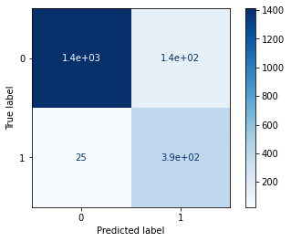 32

Visualize the confusion matrix 32

4.1.4 Accuracy score and Classification report: 32

4.2 Decision Tree 33

4.2.1 Model Building and Fitting Process: 33

4.2.2 Prediction Process: 33

4.2.3 Confusion Matrix: 33

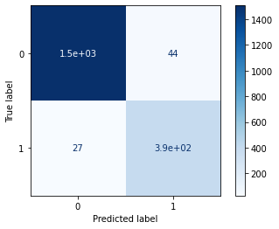 33

Visualize the confusion matrix 33

4.2.4 Accuracy score and Classification report: 34

4.3 RANDOM FOREST 34

4.3.1 Model Building and Fitting Process: 34

4.3.2 Prediction Process: 35

4.3.3 Confusion Matrix: 35

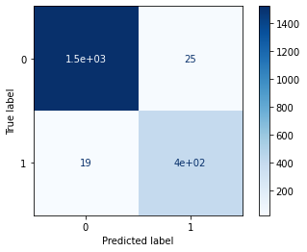 35

Visualize the confusion matrix 35

4.3.4 Accuracy score and Classification report: 36

4.4 XGB Classifier: 36

4.4.1 Model Building and Fitting Process: 36

4.4.2 Prediction Process: 37

4.4.3 Confusion Matrix: 37

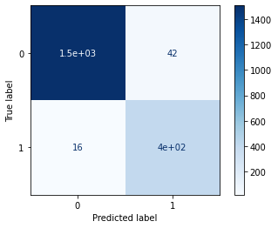 37

Visualize the confusion matrix 37

4.4.4 Accuracy score and Classification report: 38

4.4.5 ROC Curve for XGB: 38

4.5 K-Nearest Neighbors: 39

4.5.1 Model Building and Fitting Process: 39

4.5.2 Prediction Process: 39

4.5.3 Confusion Matrix: 40

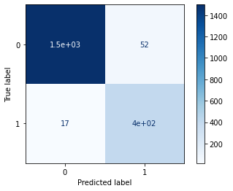 40

Visualize the confusion matrix 40

4.5.4 Accuracy Score and Classification Report: 40

4.6 Voting Method for Some Models: 41

4.6.1 Pre Processing Pipeline:. 41

4.6.2 Evaluate Model: 41

4.6.3 Accuracy score and F1 Score: 41

4.7 Artificial Neural Network 42

4.7.1 Model Building and Fitting Process: 42

4.7.2 Prediction Process: 43

4.7.3 Confusion Matrix: 43

4.7.4 Accuracy Score: 44

4.7.5 Model Loss and Accuracy Visualization: 44

C H A P T E R -5 45

5.1 Performance Comparison for all the models: 46

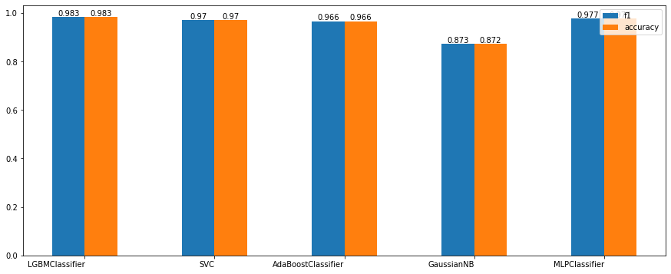 46

5.2 Conclusion: 47

# C H A P T E R -1

# I N T R O D U C T I O N

**_______________________________________________________________**

## Title & Objective of the study

In this section Im present my interest in the detection Fraud Transaction of Ethereum, specifically on the Ethereum network, and a structured approach to address the numerous anomalous transactions. Providing the overall scope of my work, Im also discern the main three entities which may profit from such a developed tool.

## Need of the Study

Ever since the advent of internet the digital revolution has rising and has creeped into all aspects to our lives. One of the most important digital revolution happend in financial system and especially transacting crypto to someone from any part of the world digitally. Digital transactions have become a part of daily life like purchasing a product online using crypto, sending crypto to friends, investing cash in crypto currencies etc., They had a lot of benefits so does paved way for fradulent activities. People started using digital crypto transactions medium to launder crypto and make the crypto look like it comes from a legal source. To find the patterns of transactions performed and help algorithms learn those patterns in identifying the fradulent transactions and flag them

## Data Sources and Description

The Dataset under study consists of the information about the fraud and valid transactions made over Ethereum.

Here is a description of the rows of the dataset:

* Index: the index number of a row
* Address: the address of the ethereum account
* FLAG: whether the transaction is fraud or not
* Avg min between sent tnx: Average time between sent transactions for account in minutes
* Avgminbetweenreceivedtnx: Average time between received transactions for account in minutes
* TimeDiffbetweenfirstand_last(Mins): Time difference between the first and last transaction
* Sent_tnx: Total number of sent normal transactions
* Received_tnx: Total number of received normal transactions
* NumberofCreated_Contracts: Total Number of created contract transactions
* UniqueReceivedFrom_Addresses: Total Unique addresses from which account received transactions
* UniqueSentTo_Addresses20: Total Unique addresses from which account sent transactions
* MinValueReceived: Minimum value in Ether ever received
* MaxValueReceived: Maximum value in Ether ever received
* AvgValueReceived5Average value in Ether ever received
* MinValSent: Minimum value of Ether ever sent
* MaxValSent: Maximum value of Ether ever sent
* AvgValSent: Average value of Ether ever sent
* MinValueSentToContract: Minimum value of Ether sent to a contract
* MaxValueSentToContract: Maximum value of Ether sent to a contract
* AvgValueSentToContract: Average value of Ether sent to contracts
* TotalTransactions(IncludingTnxtoCreate_Contract): Total number of transactions
* TotalEtherSent:Total Ether sent for account address
* TotalEtherReceived: Total Ether received for account address
* TotalEtherSent_Contracts: Total Ether sent to Contract addresses
* TotalEtherBalance: Total Ether Balance following enacted transactions
* TotalERC20Tnxs: Total number of ERC20 token transfer transactions
* ERC20TotalEther_Received: Total ERC20 token received transactions in Ether
* ERC20TotalEther_Sent: Total ERC20token sent transactions in Ether
* ERC20TotalEtherSentContract: Total ERC20 token transfer to other contracts in Ether
* ERC20UniqSent_Addr: Number of ERC20 token transactions sent to Unique account addresses
* ERC20UniqRec_Addr: Number of ERC20 token transactions received from Unique addresses
* ERC20UniqRecContractAddr: Number of ERC20token transactions received from Unique contract addresses
* ERC20AvgTimeBetweenSent_Tnx: Average time between ERC20 token sent transactions in minutes
* ERC20AvgTimeBetweenRec_Tnx: Average time between ERC20 token received transactions in minutes
* ERC20AvgTimeBetweenContract_Tnx: Average time ERC20 token between sent token transactions
* ERC20MinVal_Rec: Minimum value in Ether received from ERC20 token transactions for account
* ERC20MaxVal_Rec: Maximum value in Ether received from ERC20 token transactions for account
* ERC20AvgVal_Rec: Average value in Ether received from ERC20 token transactions for account
* ERC20MinVal_Sent: Minimum value in Ether sent from ERC20 token transactions for account
* ERC20MaxVal_Sent: Maximum value in Ether sent from ERC20 token transactions for account
* ERC20AvgVal_Sent: Average value in Ether sent from ERC20 token transactions for account
* ERC20UniqSentTokenName: Number of Unique ERC20 tokens transferred
* ERC20UniqRecTokenName: Number of Unique ERC20 tokens received
* ERC20MostSentTokenType: Most sent token for account via ERC20 transaction
* ERC20MostRecTokenType: Most received token for account via ERC20 transactions.

The Dataset contains 9841 rows and 51 columns

## Aims and objectives

* Exploratory analysis of data to extract the pattern of fraudlent activites
* Build a machine learning model to classify fraud and non-fraud transactions.
* Reduce the false negatives by tuning the model.

## 1.5 Tools & Techniques

Tools: Google Colab

Techniques:

* Supervised Learning Models: LogisticRegression, DecisionTree, Random Forest, XGB, KNN, LGBM, SVC, AdaBoost, GaussianNB, MLP.
* Deep Learning Model: Artificial Neural Network.

## Overview of the proposed solution

In order to achieve the desired outcome, the proposed solution can be broken down into 7 key steps as depicted in the Process chart Fig. 1.1. These include the i) We have to import the dataset, respectively; ii) executing exploratory data analysis; iii) visualize the Data for some conclusion; iv) preprocessing the data for the model building; v) Applying a ML technique and classifying with Different Models; vi) utilize a visualizations to display the results in an easy to understand manner; vii) conclusion the above results. Each process is fully dependent on the preceding steps and would therefore have a direct impact on the final results obtained by the machine learning (ML) algorithms.

Figure 1.1: Architectural overview of proposed solution.

# C H A P T E R -2

# D A T A P R E P A R A T I O N A N D U N D E R S T A N D I N G

**________________________________________________________________**

## 2.1 Data Extraction and Cleaning:

At first step we have to import the Libraries that we need for computation and processing

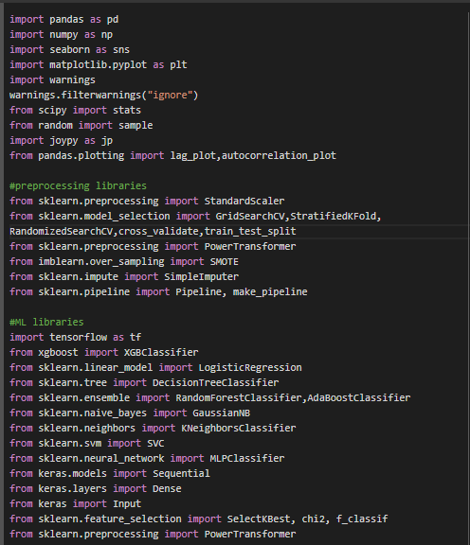

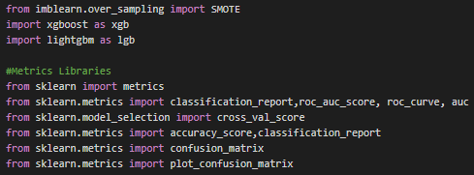

**The Dataset contains 9841 records and 51 Columns. And at first step we have to import the Dataset into python by using Pandas function. Since, it’s a CSV file so we have to do as follows,**

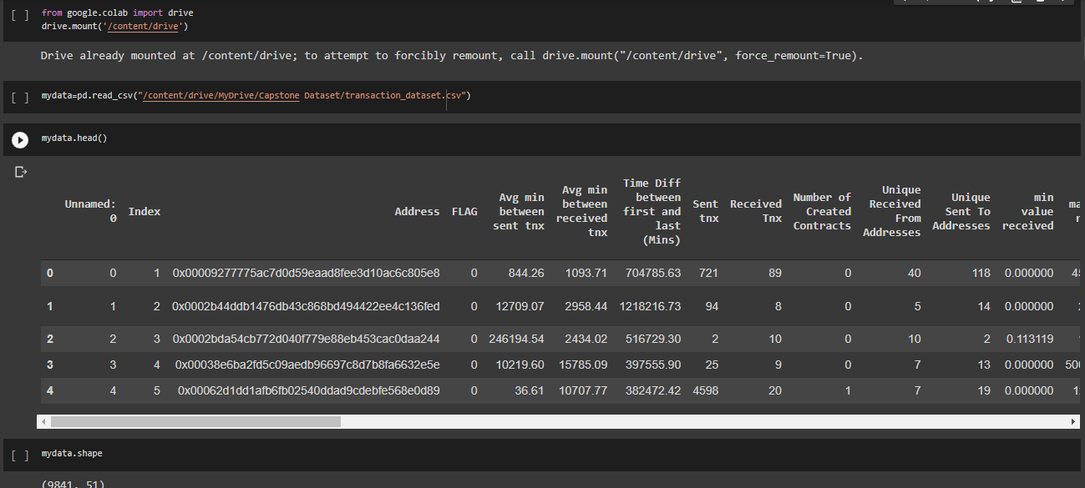

* **Information about the dataset**

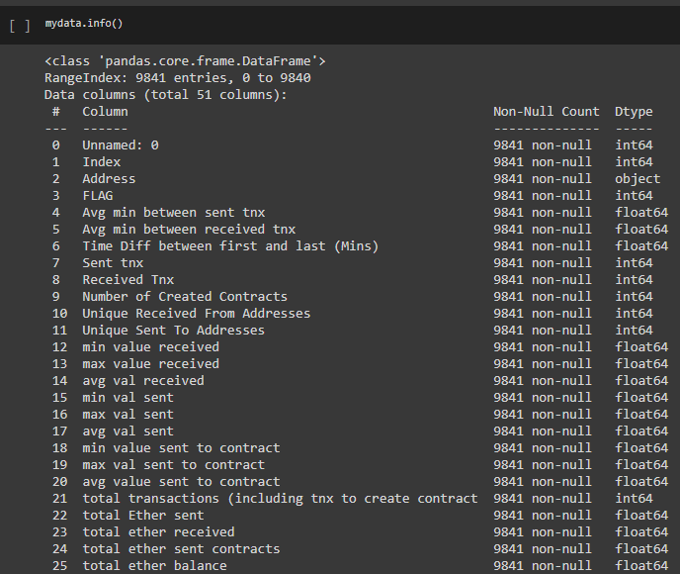

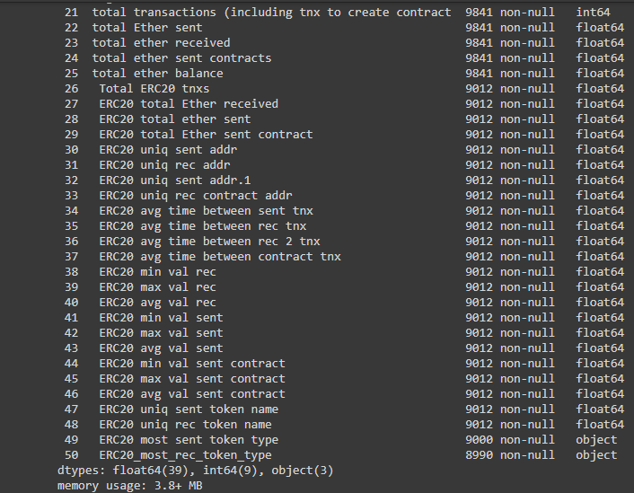

* **Describe about the dataset**

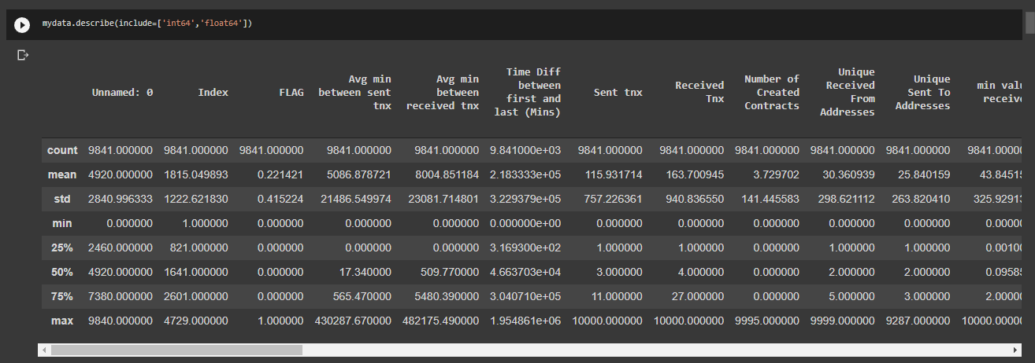

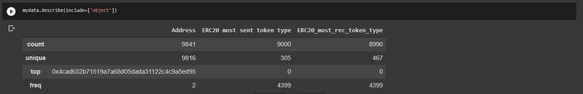

## ****Exploratory Data Analysis:****

It is a good practice to understand the data first and try to gather as many insights from it. EDA is all about making sense of data in hand, before getting them dirty with it.

* **Missing Values Treatment**

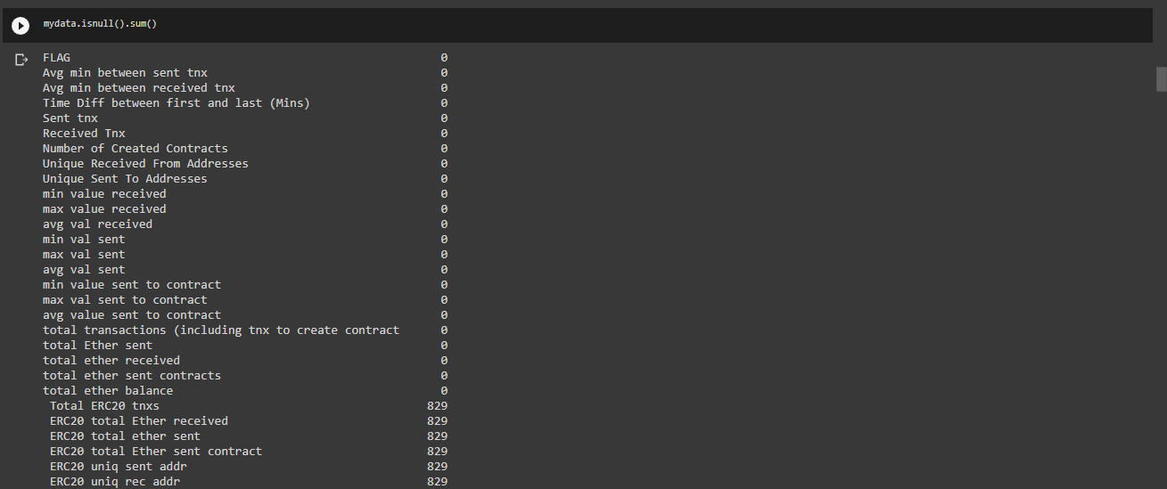

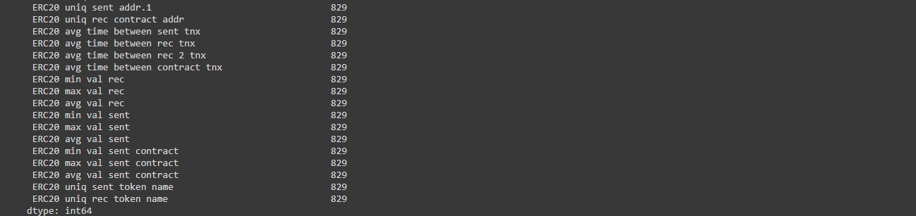

By looking the above picture we got some missing value, As we expected every missing value is in fraud rows. That means that almost 40% of fraud rows have missing values.

So, we have to fill the missing value with median of the data’s.

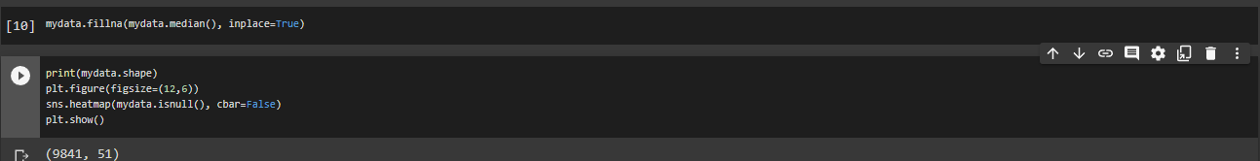

After filling the missing values the dataset looks like,

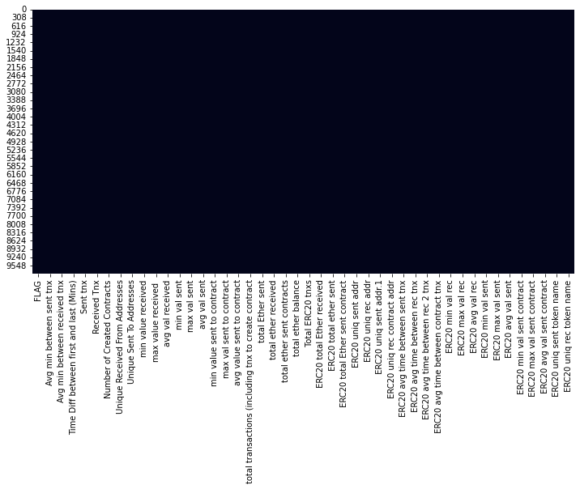

* **Dropping unnecessary columns**

We don’t need the Unnamed: 0, ERC20_most_rec_token_type, ERC20 most sent token type, Address and we don’t required Index as it is just an outcome of current algorithm.

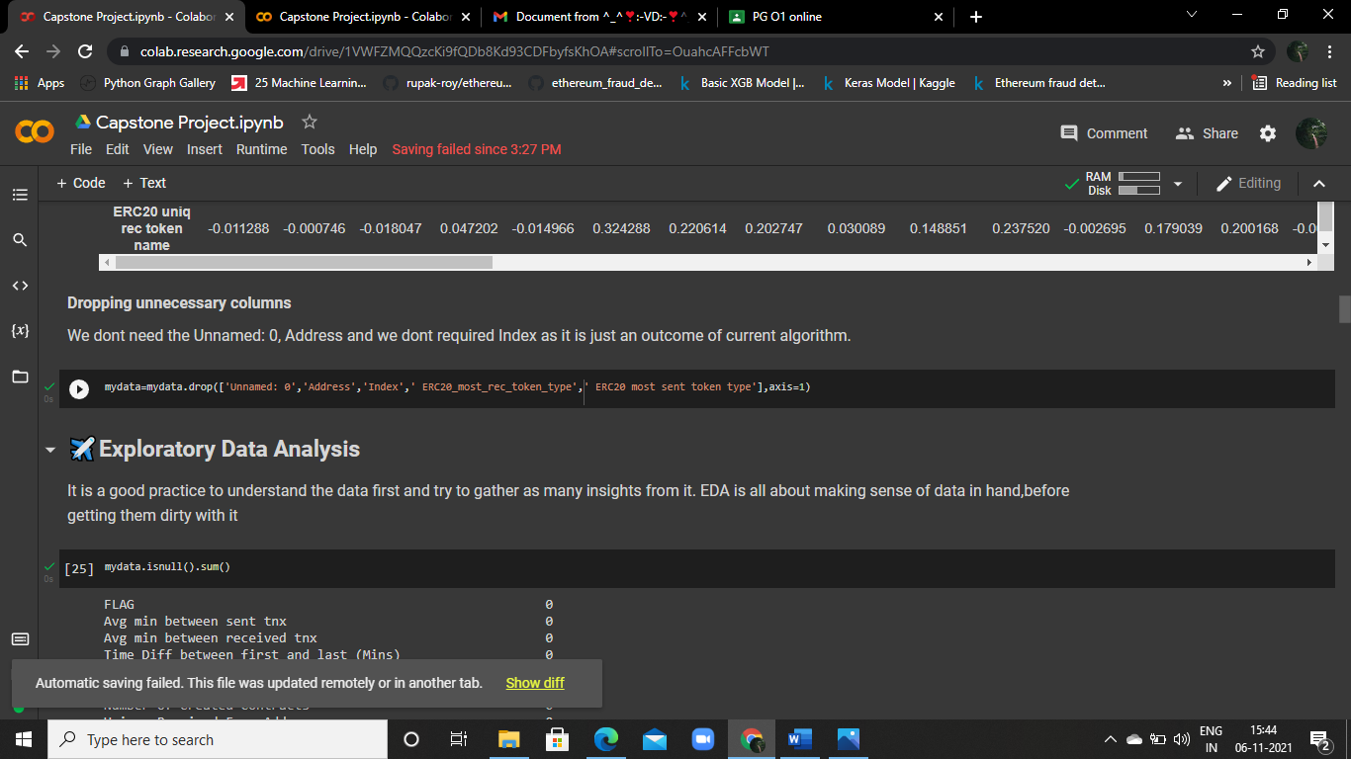

* **We can check how many fraudile transactions there are in the dataset**

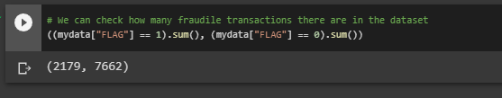

* **Feature Extraction**

Feature selection is the process of isolating the most consistent, non-redundant, and relevant features to use in model construction. Methodically reducing the size of datasets is important as the size and variety of datasets continue to grow. The main goal of feature selection is to improve the performance of a predictive model and reduce the computational cost of modeling

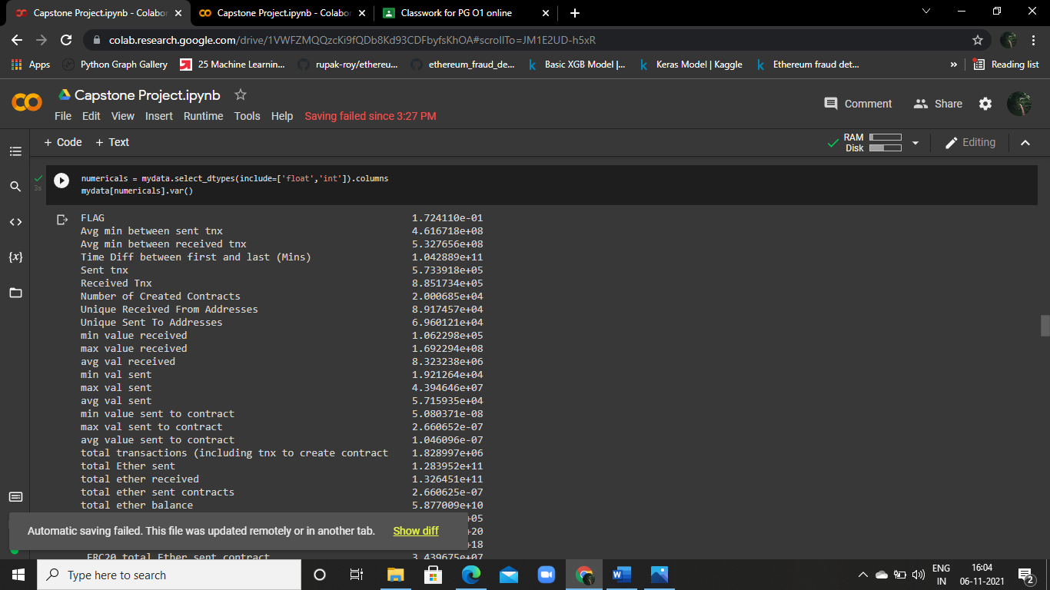

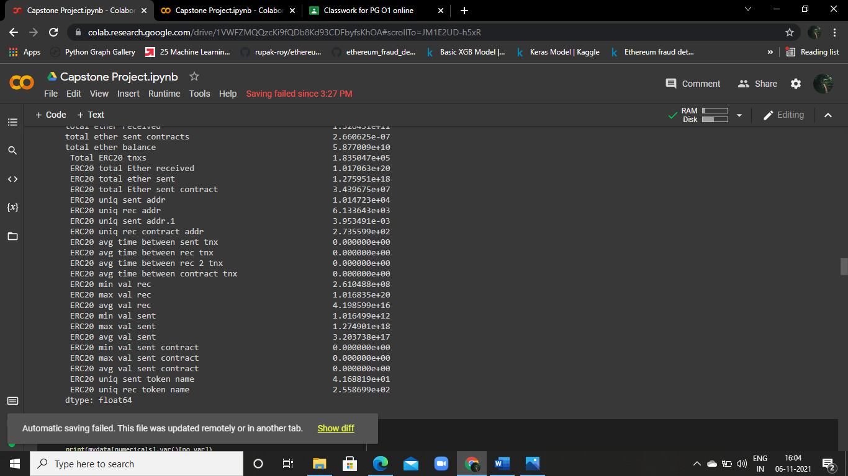

Filtering the features with 0 variance and Drop the features with 0 variance because these features will not help in the performance of the model

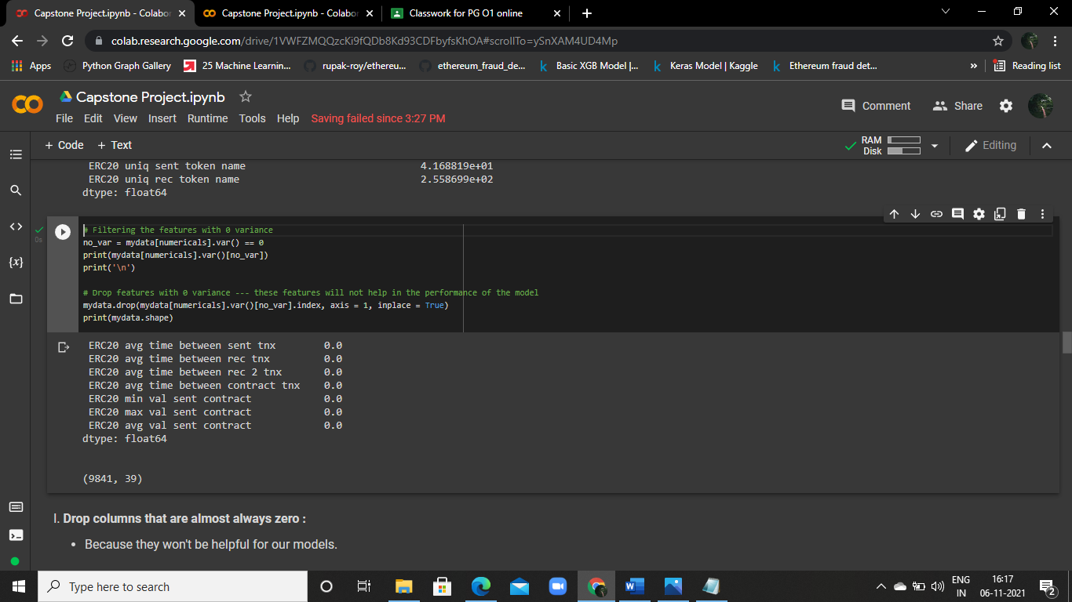

Drop columns that are almost always zero because they won't be helpful for our models.

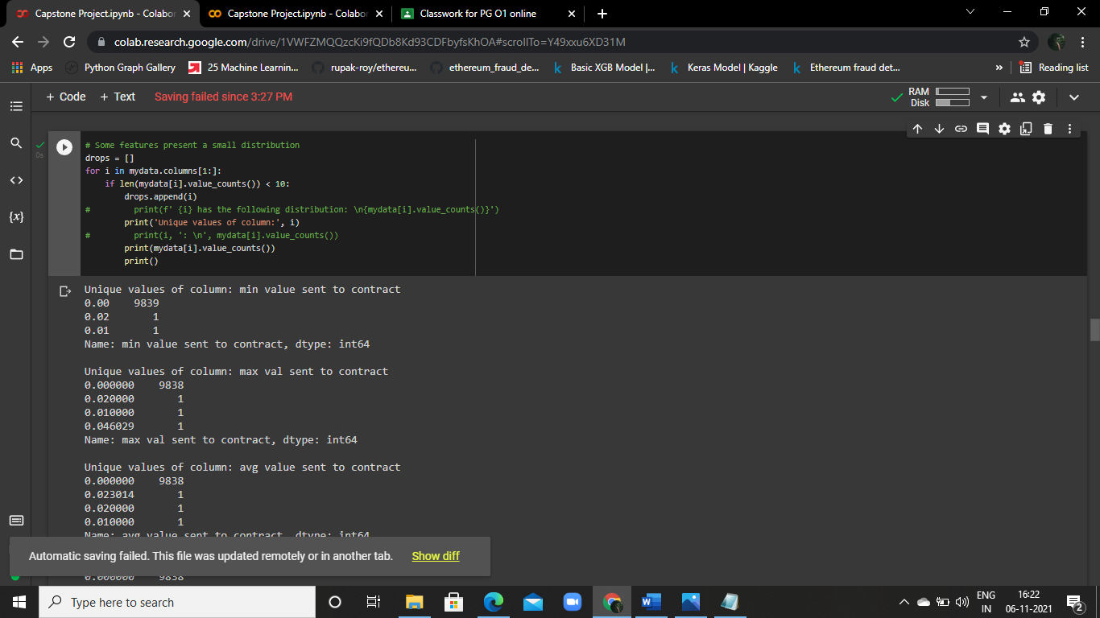

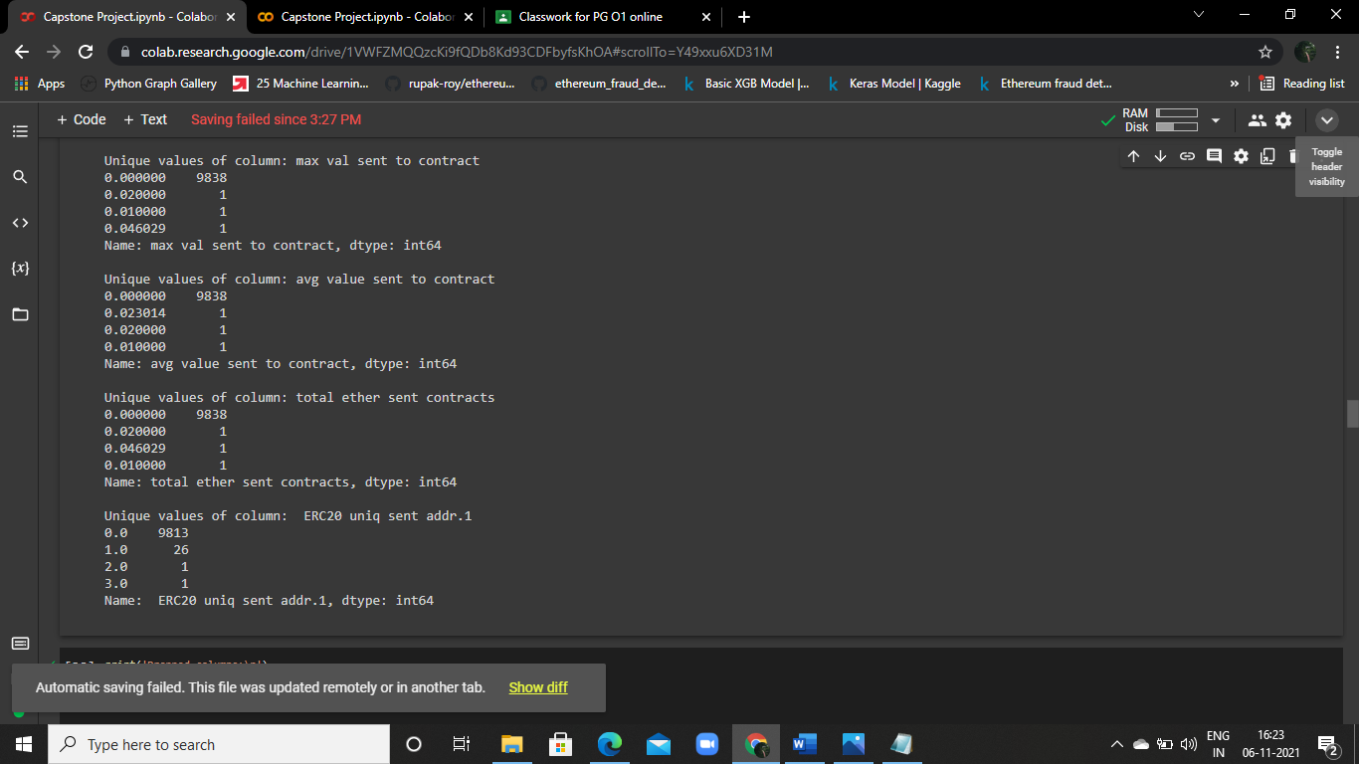

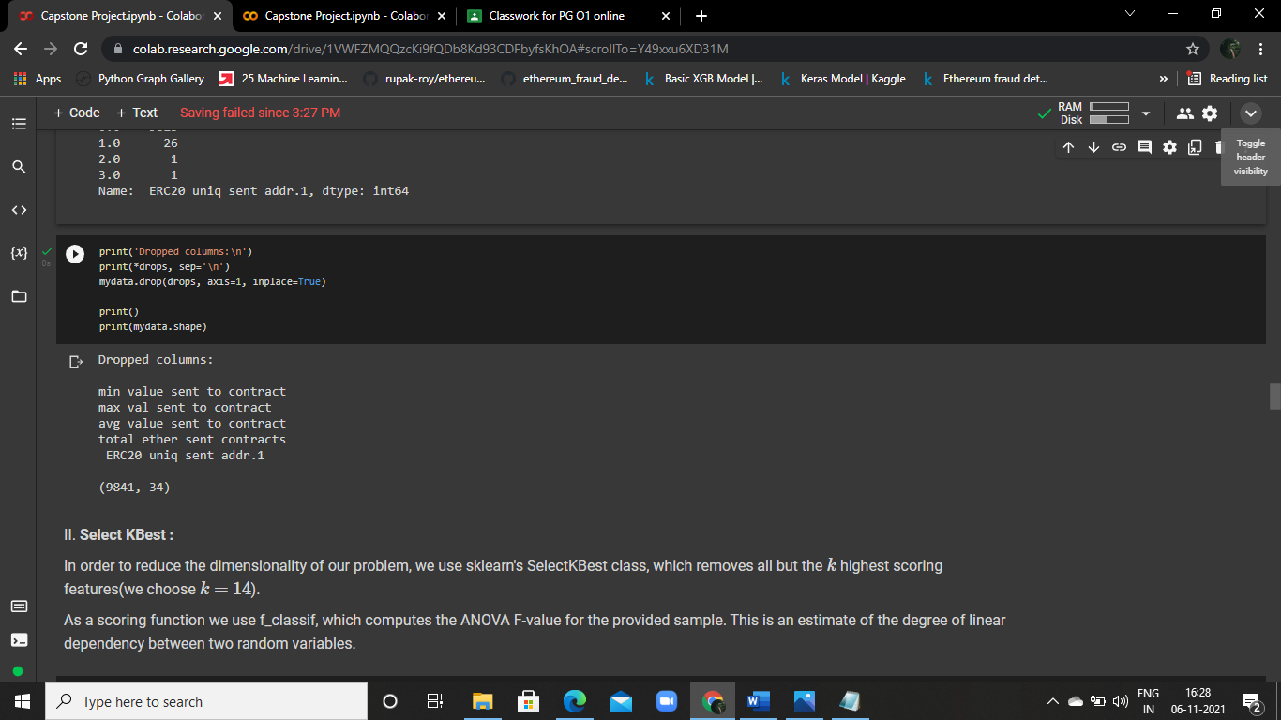

## ****2.3 Data Visualization****

Data visualization is one of the steps of the data science process, which states that after data has been collected, processed and modeled, it must be visualized for conclusions to be made.

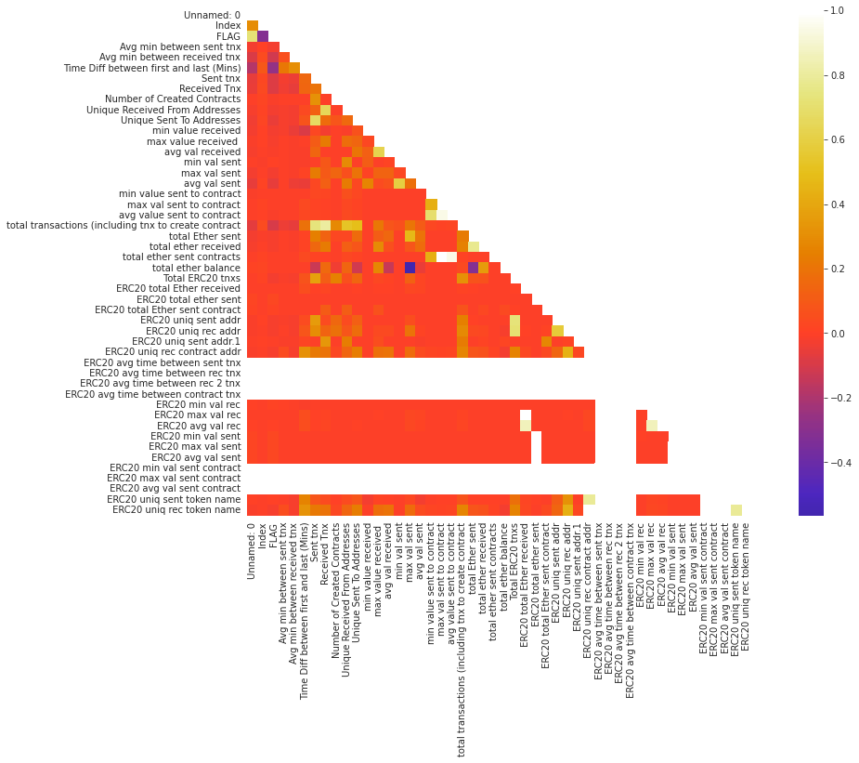

This corr plot shows that How the features are correlated with other features. By looking this plot we have to conclude that which features are highly correlated with others and low correlated with others.

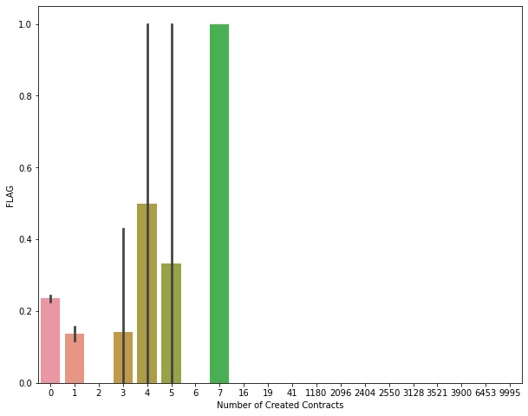

By looking this above plot, we can see that the more contacts a user has created, the more likely they are to be of a fraudulent transaction.

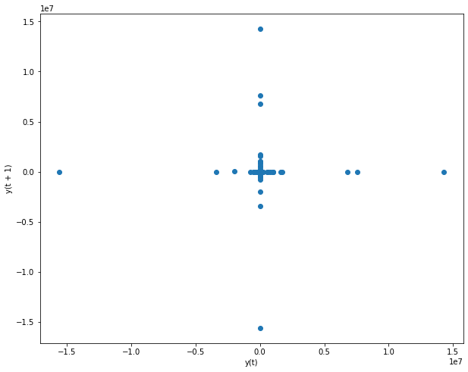

The lag plot shows that with many of the points clustered at the corner, showing us that the data has a few non-zero values, but the points are mainly non-zero, and do not follow any trend

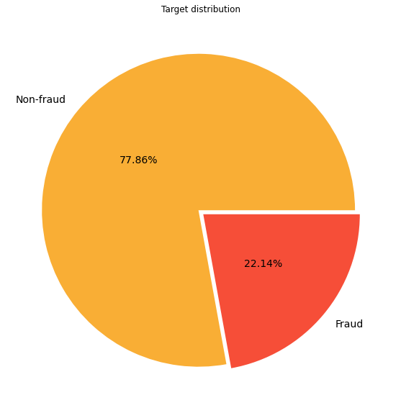

In this pie plot shows us the Distribution of the Flag (Target Variable). By looking this plot we have to conclude that the Non-fraud transaction having the most of the distribution in the dataset.

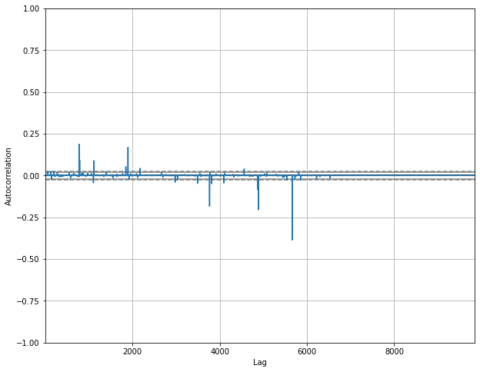

Clearly here we can see that the majority of the data points are random, with the autocorrelation plot showing us that most of the points are located in the 99% confidence band.

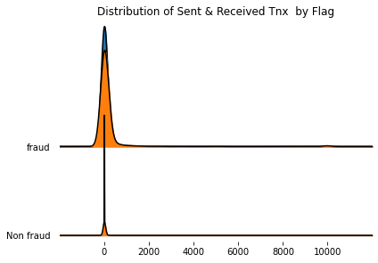

By looking the above Joy plot we have to conclude that the Distribution of Sent and Received Tnx by Flag.

## 2.4 Feature Engineering

Feature engineering is the process of transforming raw data into features that better represent the underlying problem to the predictive models, resulting in improved model accuracy on unseen data.

* **Reduce the Dimensionality**

In order to reduce the dimensionality of our problem, we use sklearn's Select KBest class, which removes all but the k highest scoring features (we choose k=14).

As a scoring function we use f_classif, which computes the ANOVA F-value for the provided sample. This is an estimate of the degree of linear dependency between two random variables.

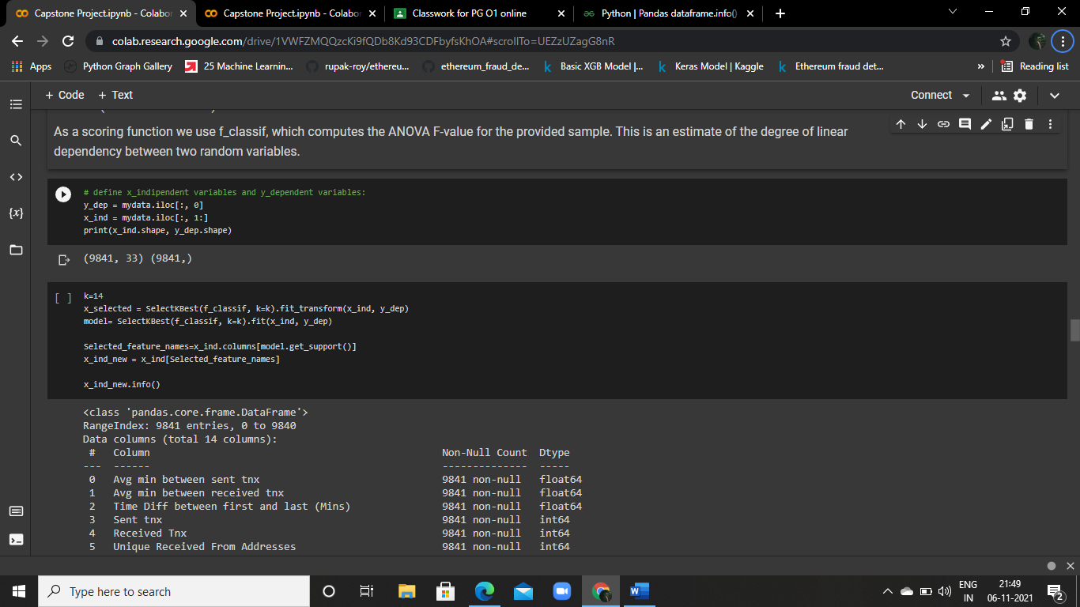

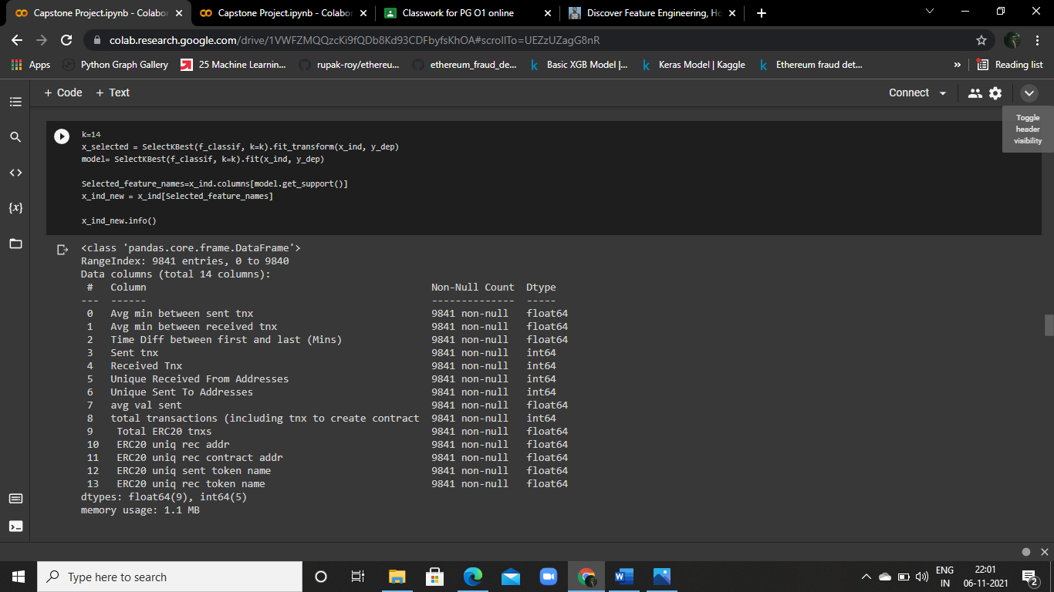

* **Treat Outliers**

We visualize the outliers using box plots

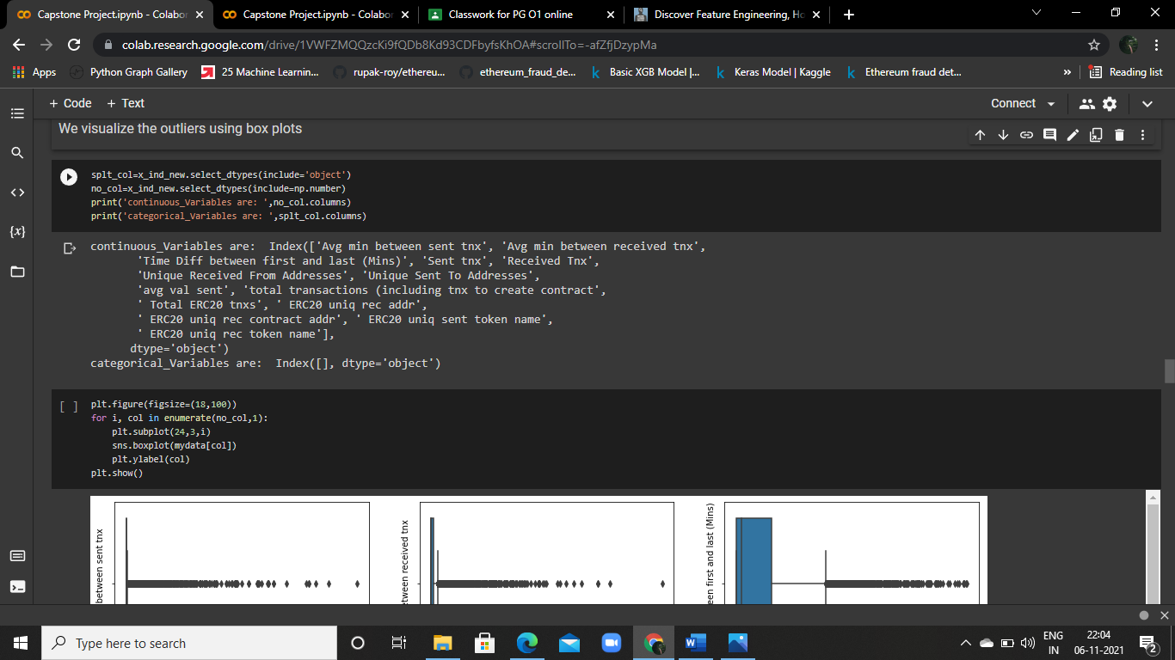

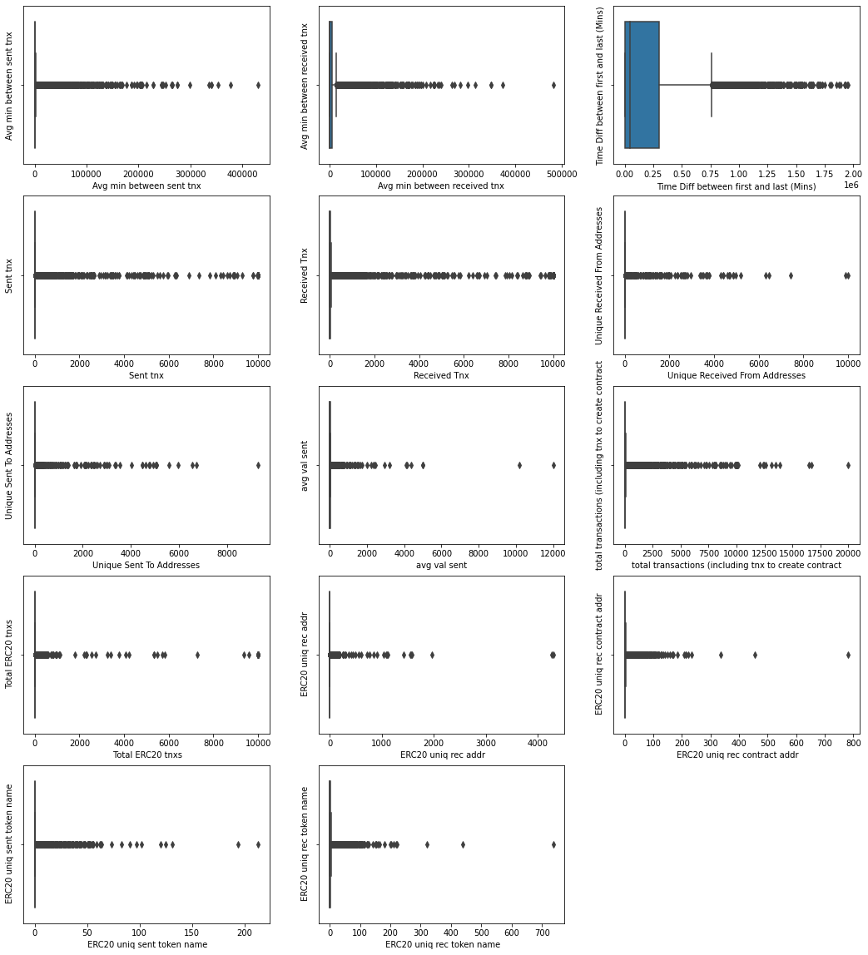

There seem to be so many outliers it is likely that the distribution is far from Gaussian, and thus they shouldn't be considered outliers

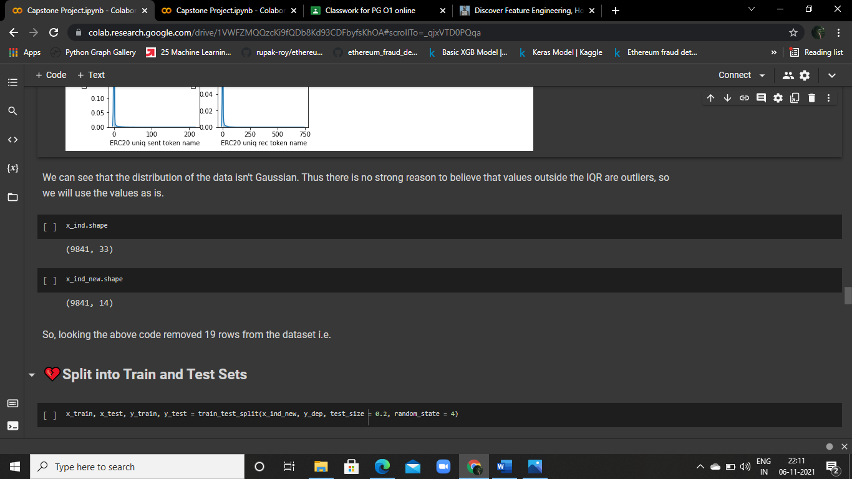

So, looking the above code removed 19 rows from the dataset

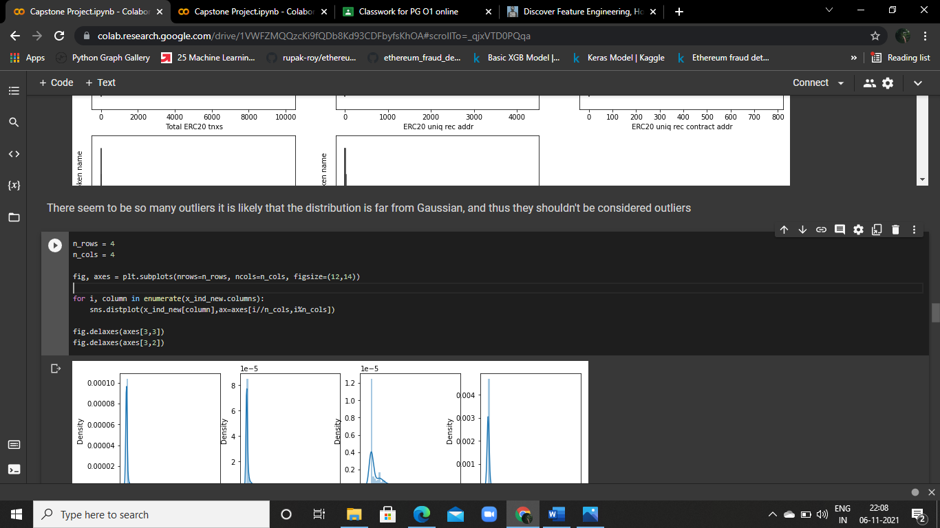

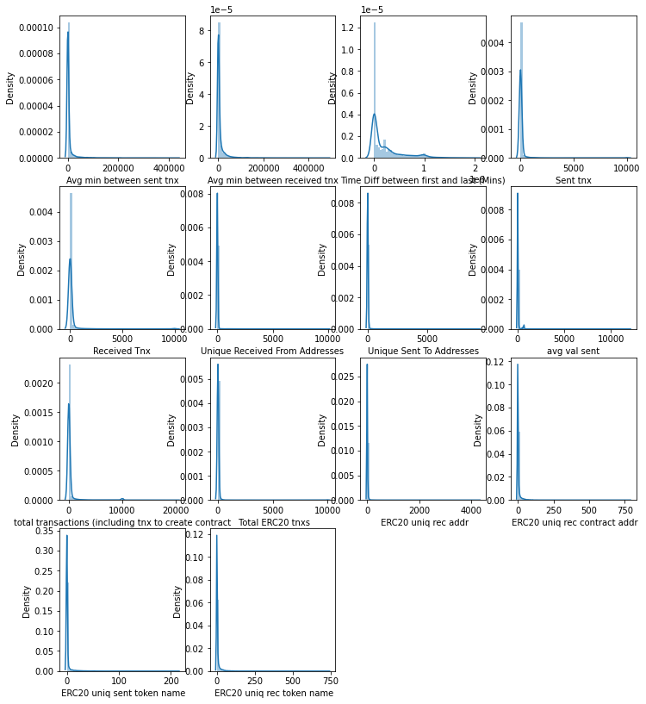

We can see that the distribution of the data isn't Gaussian. Thus there is no strong reason to believe that values outside the IQR are outliers, so we will use the values as is.

## 2.3 ****Split into Train and Test Sets****

The train-test split is a technique for evaluating the performance of a machine learning algorithm. It can be used for classification or regression problems and can be used for any supervised learning algorithm. The procedure involves taking a dataset and dividing it into two subsets.

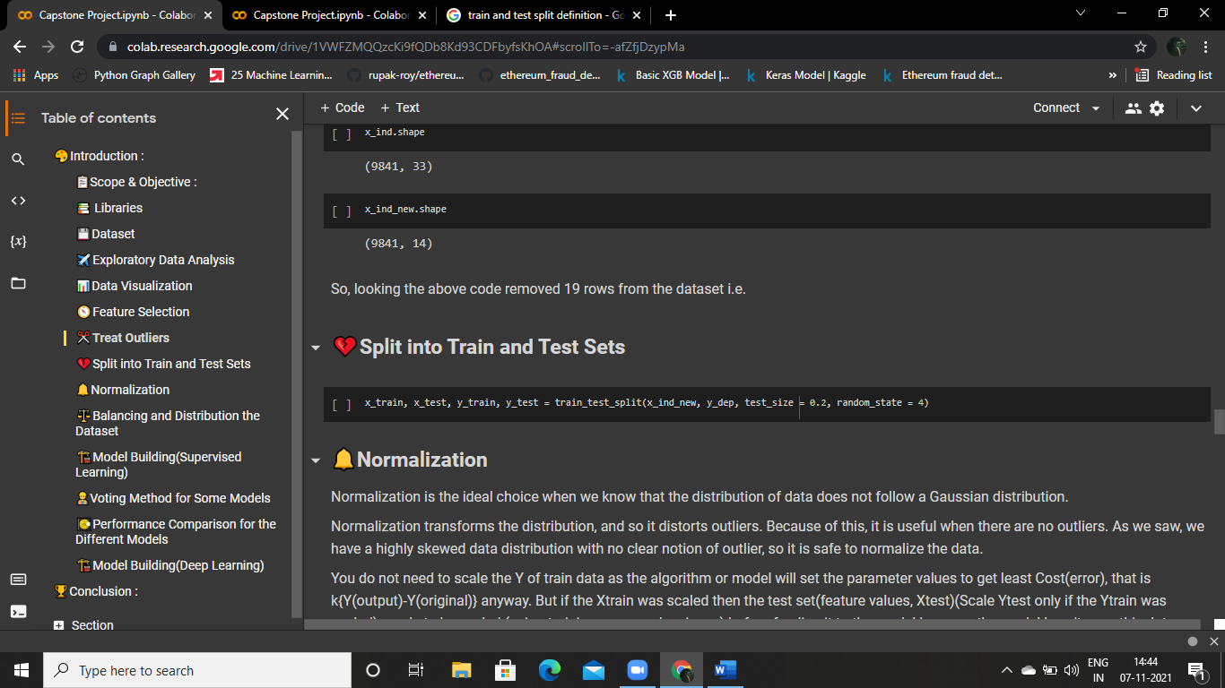

## 2.4 ****Normalization****

Normalization is the ideal choice when we know that the distribution of data does not follow a Gaussian distribution.

Normalization transforms the distribution, and so it distorts outliers. Because of this, it is useful when there are no outliers. As we saw, we have a highly skewed data distribution with no clear notion of outlier, so it is safe to normalize the data.

You do not need to scale the y of train data as the algorithm or model will set the parameter values to get least Cost(error), that is k{y(output)-y(original)} anyway. But if the x_train was scaled then the test set(feature values, x_test)(Scale y_test only if the y_train was scaled) needs to be scaled (using training mean and variance) before feeding it to the model because the model hasn't seen this data before and has been trained on data with scaled range, so if the test data has a feature value diverging from the corresponding feature range in train data by a considerably high value then the model will output a wrong prediction for the corresponding test data

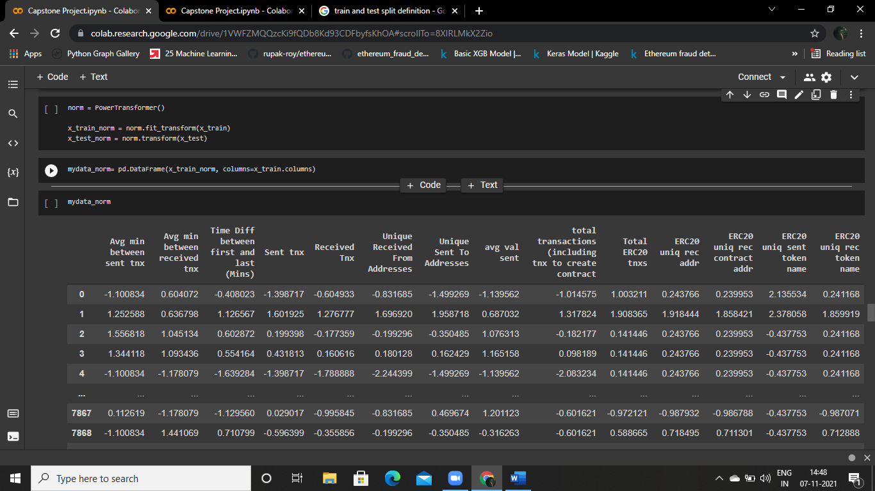

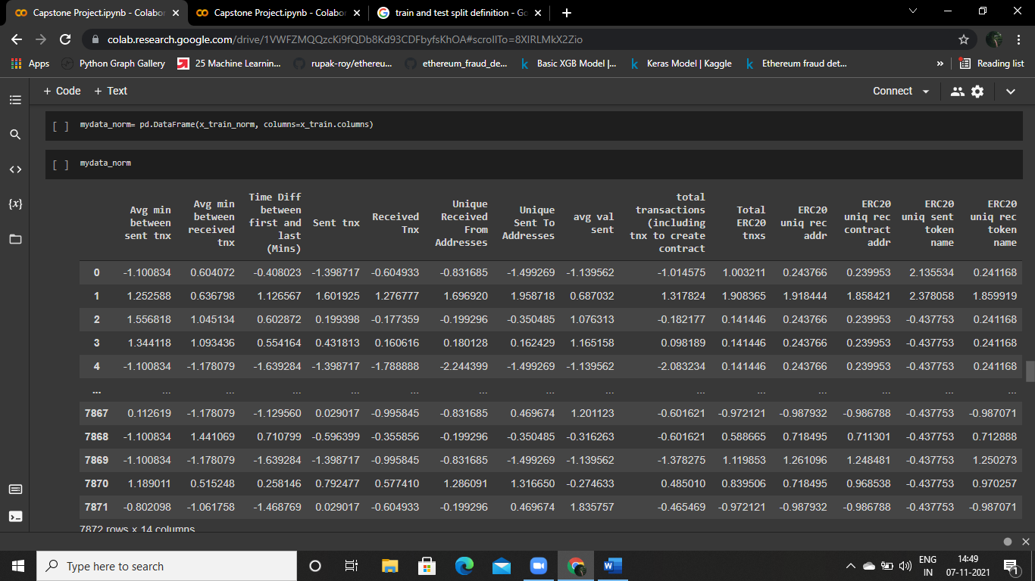

## 2.5 ****Balancing and Distribution the Dataset:****

It is crucial to have balanced class distribution, i.e., there should be no significant difference between positive and negative classes. The models trained on datasets with imbalanced class distribution tend to be biased and show poor performance toward minor class.

We use Synthetic Minority Oversampling Technique (SMOTE). This technique generates synthetic data for the minority class. SMOTE proceeds by joining the points of the minority class with line segments and then placing artificial points along those lines

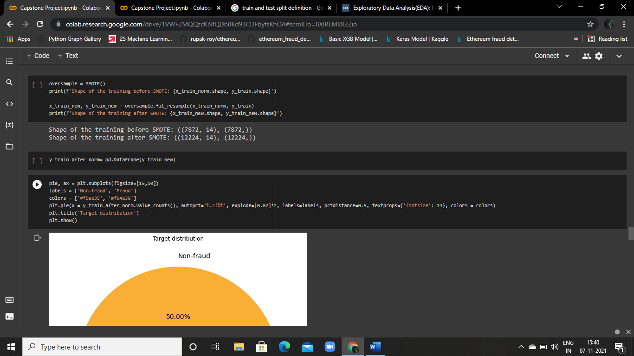

After Balancing the Dataset looks like

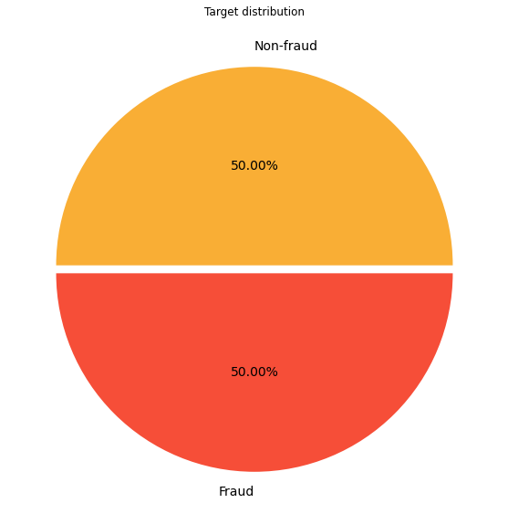

C H A P T E R -3

# M O D E L B U I L D I N G

**________________________________________________________________**

# 4.1 RANDOM FOREST

Logistic Regression is used to describe data and to explain the relationship between one dependent binary variable and one or more independent variables.

## 4.1.1 Model Building and Fitting Process:

First thing is when we received the perfect data from the EDA process. Its time to serving the data to the models.

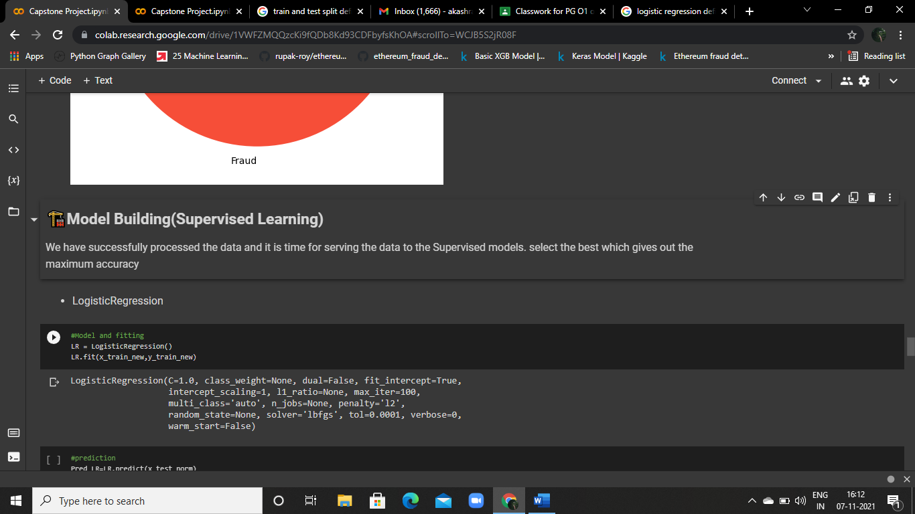

## 4.1.2 Prediction Process:

After fitting the data to the model. It’s time for prediction

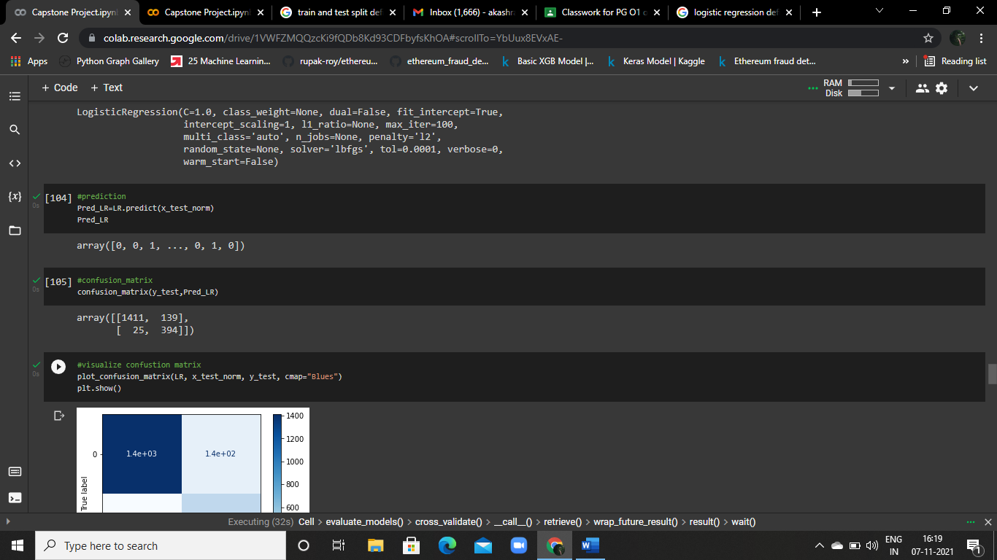

## 4.1.3 Confusion Matrix:





Visualize the confusion matrix

**Considering the confusion matrix:**

LR model, correctly identified 395 (TP) of FRAUD cases, out of 419 (P). LR model flagged as FRAUD 135 (FP) out of 1415, when this case was actually NON-FRAUD Dealing with a fraud detection scenario, we care more about the transactions that were actually FRAUDS, but which were treated as NON-FRAUD by our model (FN - 23) TYPE II ERROR

Thereby, let's try to increase the precision using other methods.

## 4.1.4 Accuracy score and Classification report:

After doing all the process we have to conclude the model performance with accuracy score and classification report.

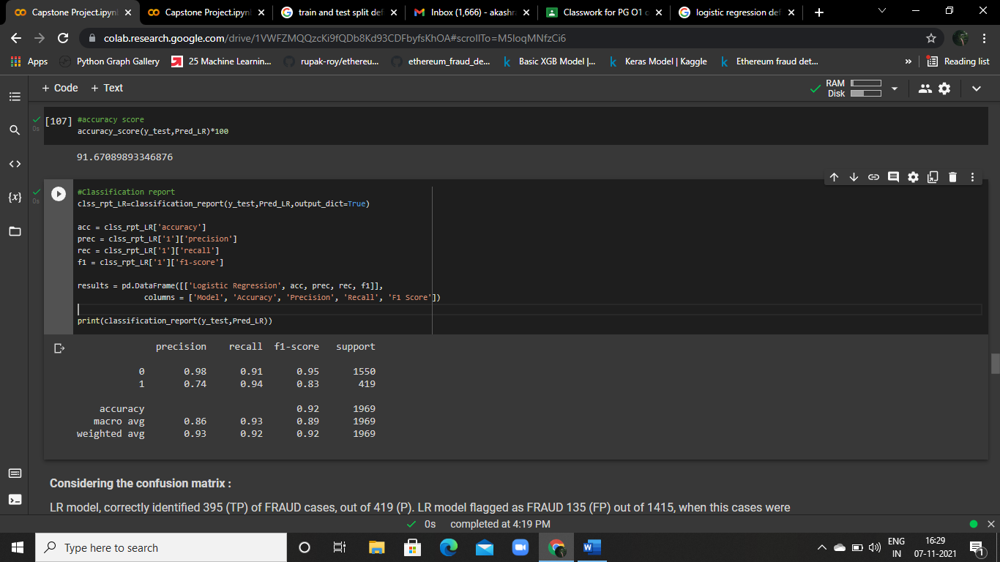

By Looking this figure the Logistic Regression Model Accuracy is 92% It’s pretty good. Let’s see the other model accuracy then we conclude it which one is Best.

# 4.2 Decision Tree

A Decision Tree is a simple representation for classifying examples. It is a Supervised Machine Learning where the data is continuously split according to a certain parameter.

## 4.2.1 Model Building and Fitting Process:

First thing is when we received the perfect data from the EDA process. Its time to serving the data to the models.

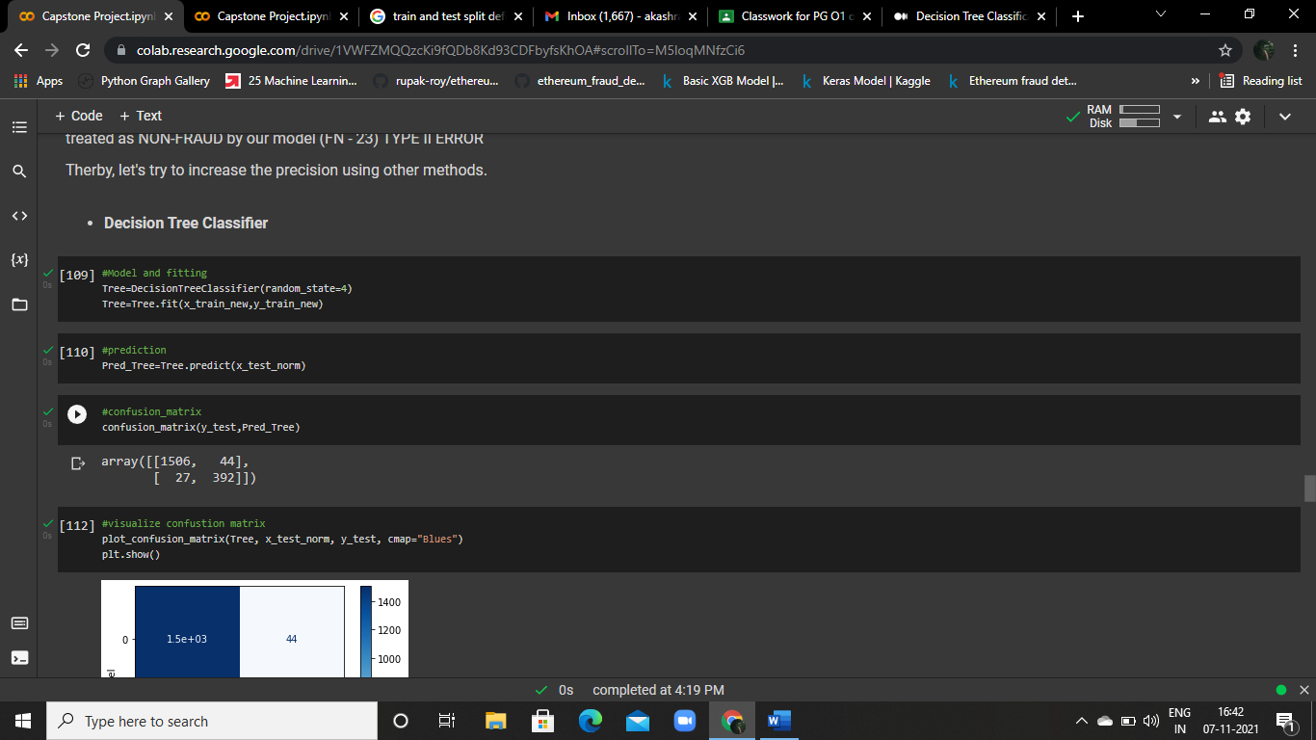

## 4.2.2 Prediction Process:

After fitting the data to the model. It’s time for prediction

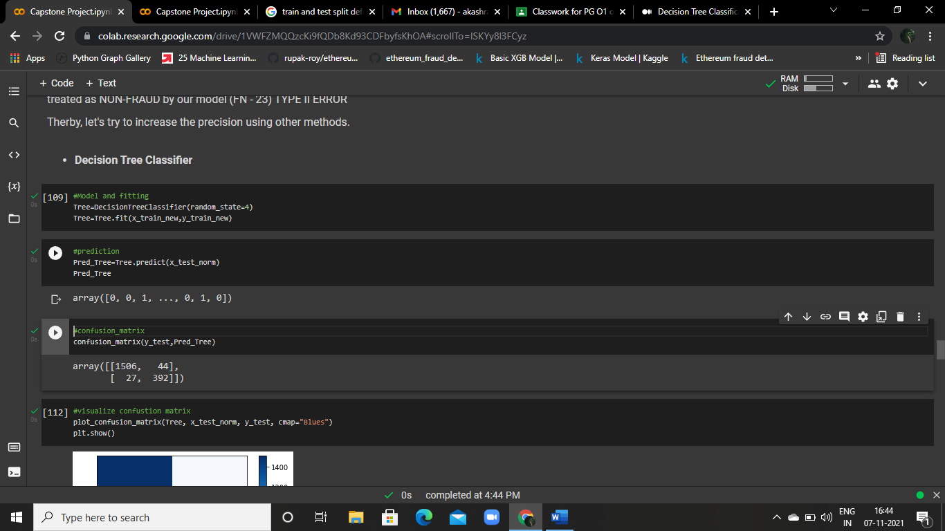

## 4.2.3 Confusion Matrix:





Visualize the confusion matrix

## 4.2.4 Accuracy score and Classification report:

After doing all the process we have to conclude the model performance with accuracy score and classification report.

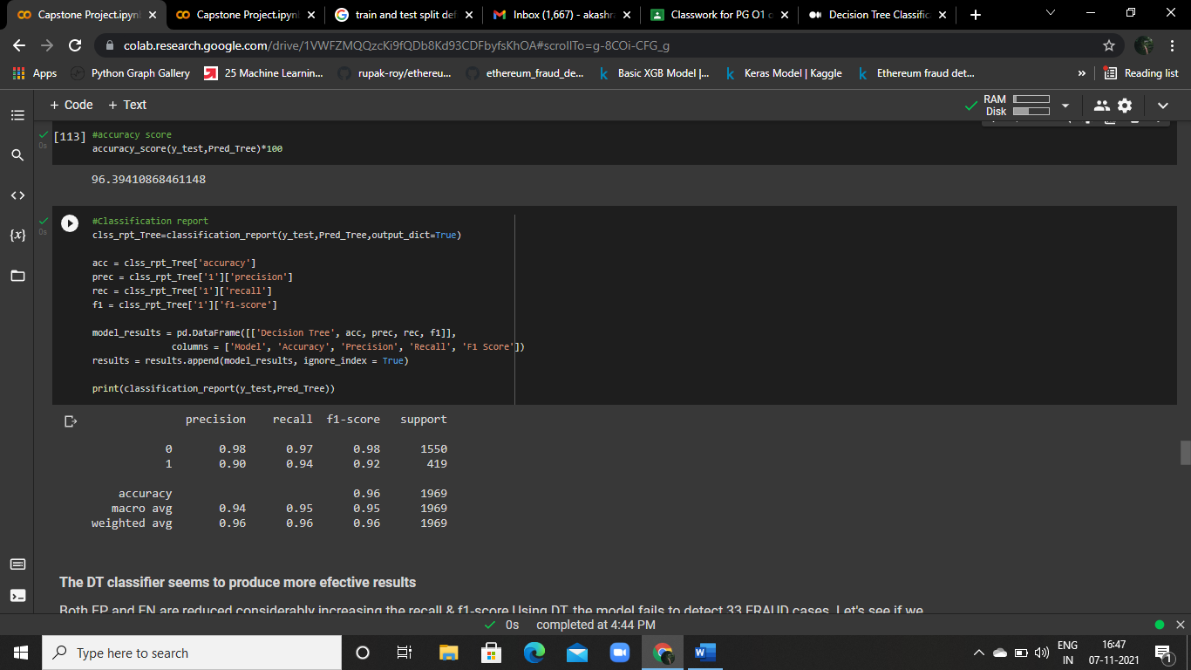

By Looking this figure the Decision Tree Model Accuracy is 96% It’s too good. Let’s see the other model accuracy then we conclude it which one is Best.

# 4.3 RANDOM FOREST

The random forest algorithm is an extension of the bagging method as it utilizes both bagging and feature randomness to create an uncorrelated forest of decision trees

## 4.3.1 Model Building and Fitting Process:

First thing is when we received the perfect data from the EDA process. Its time to serving the data to the models.

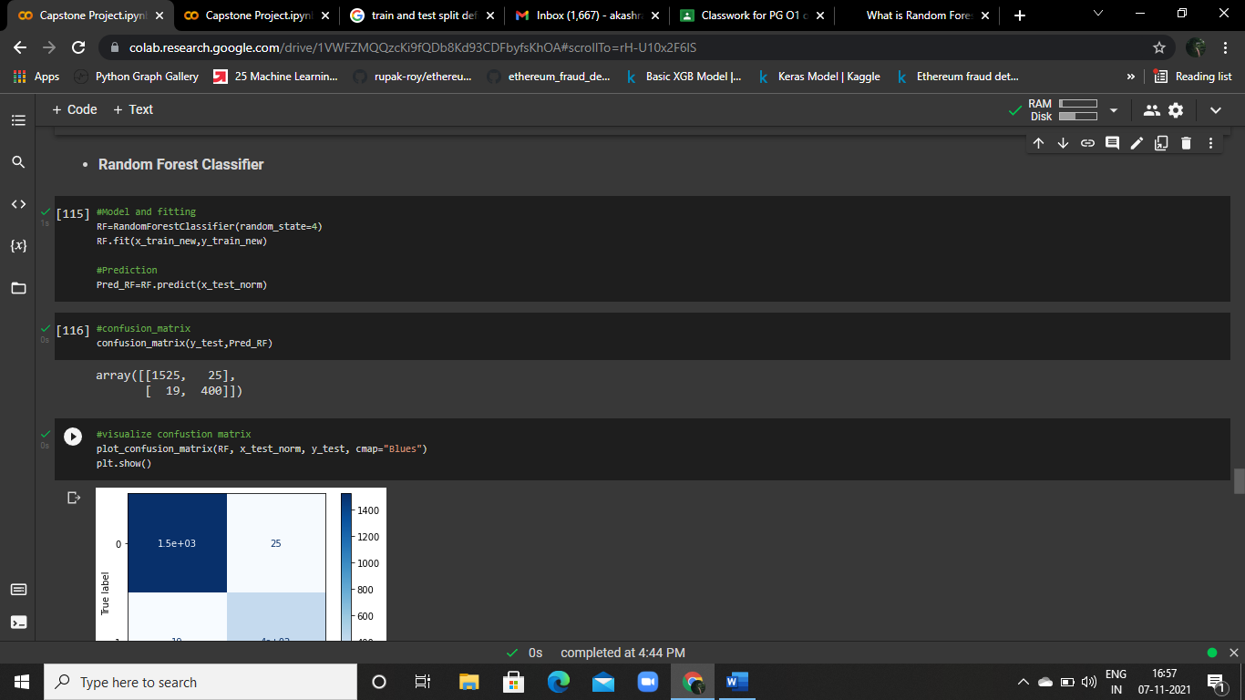

## 4.3.2 Prediction Process:

After fitting the data to the model. It’s time for prediction



## 4.3.3 Confusion Matrix:





Visualize the confusion matrix

## 4.3.4 Accuracy score and Classification report:

After doing all the process we have to conclude the model performance with accuracy score and classification report.

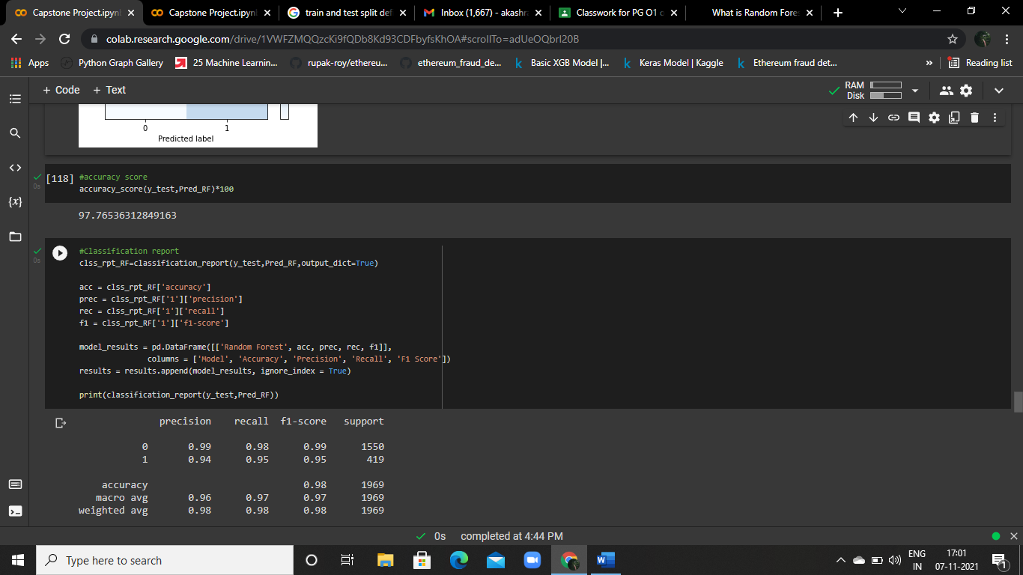

By Looking this figure the Random Forest Model Accuracy is 98% It’s good. Let’s see the other model accuracy then we conclude it which one is Best.

# 4.4 XGB Classifier:

XGB is an algorithm that has recently been dominating applied machine learning and Kaggle competitions for structured or tabular data. XGB is an implementation of gradient boosted decision trees designed for speed and performance.

## 4.4.1 Model Building and Fitting Process:

First thing is when we received the perfect data from the EDA process. Its time to serving the data to the models.

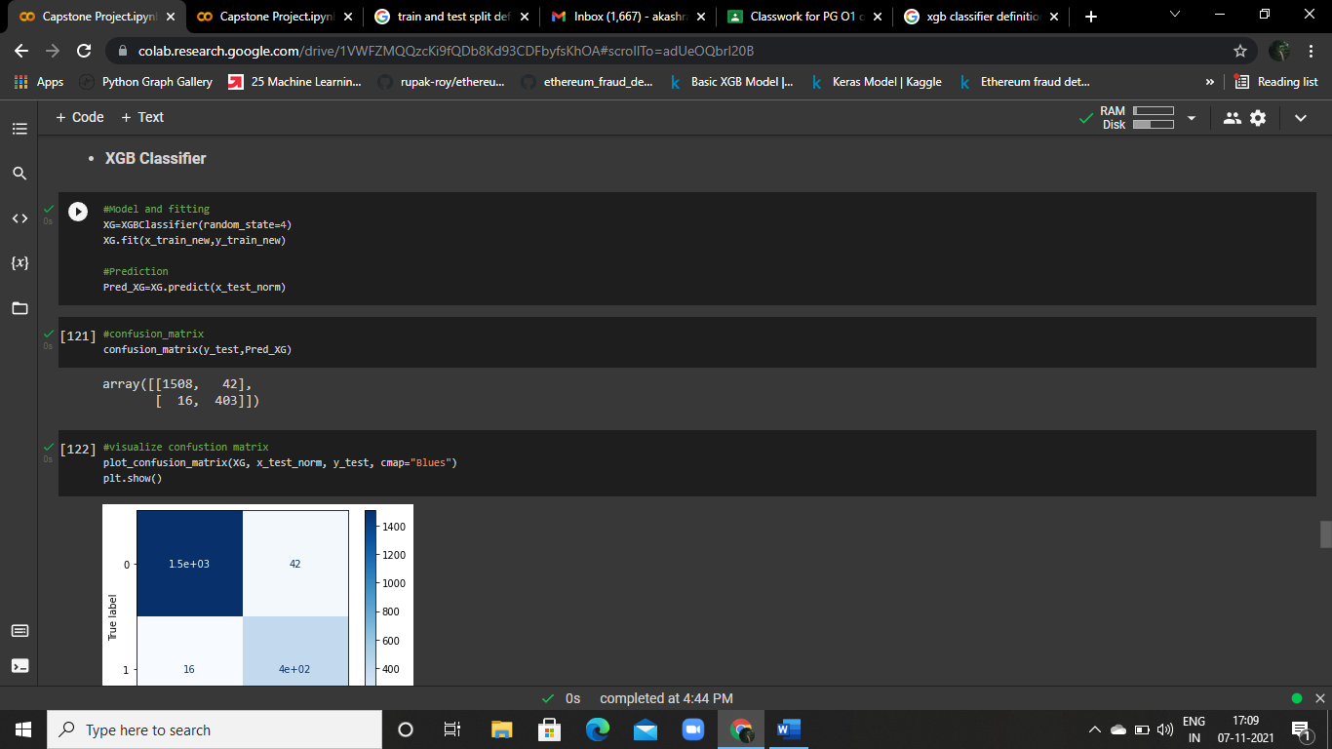

## 4.4.2 Prediction Process:

After fitting the data to the model. It’s time for prediction



## 4.4.3 Confusion Matrix:





Visualize the confusion matrix

## 4.4.4 Accuracy score and Classification report:

After doing all the process we have to conclude the model performance with accuracy score and classification report.

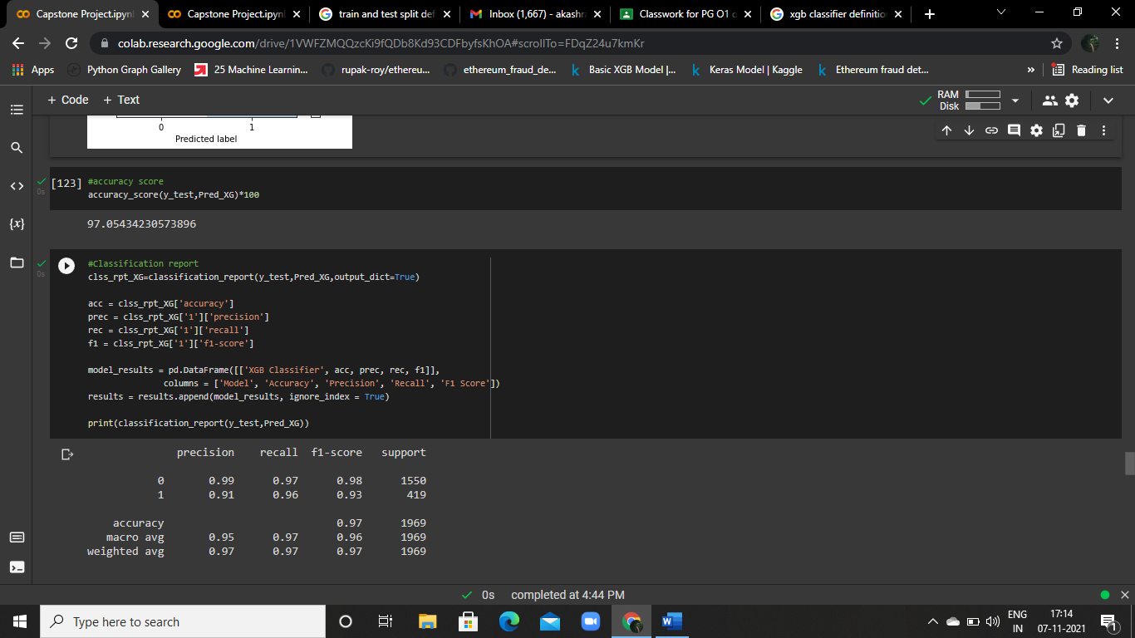

By Looking this figure the XGB Model Accuracy is 97% It’s good. Let’s see the other model accuracy then we conclude it which one is Best.

## 4.4.5 ROC Curve for XGB:

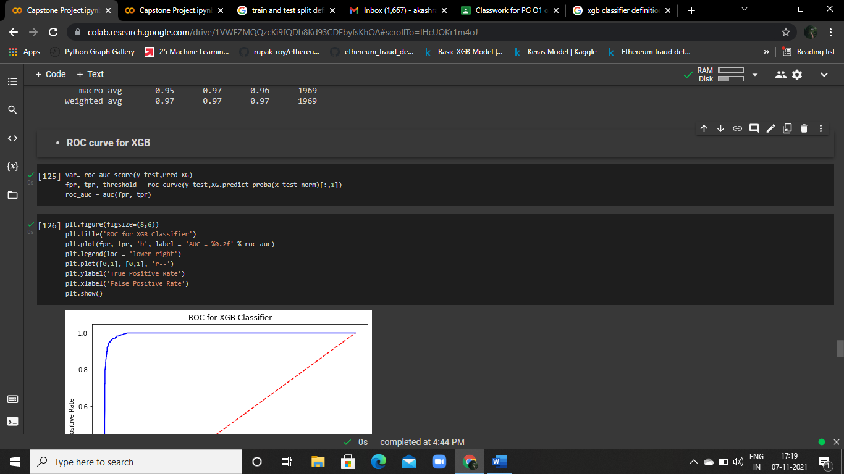

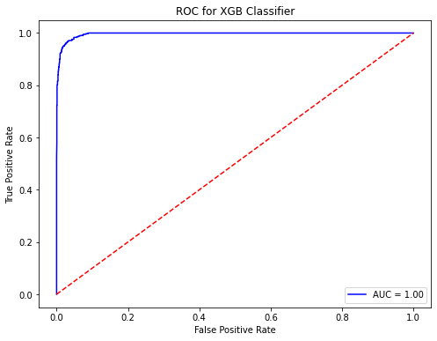

# 4.5 K-Nearest Neighbors:

A k-nearest-neighbor is a data classification algorithm that attempts to determine what group a data point is in by looking at the data points around it.

## 4.5.1 Model Building and Fitting Process:

First thing is when we received the perfect data from the EDA process. Its time to serving the data to the models.

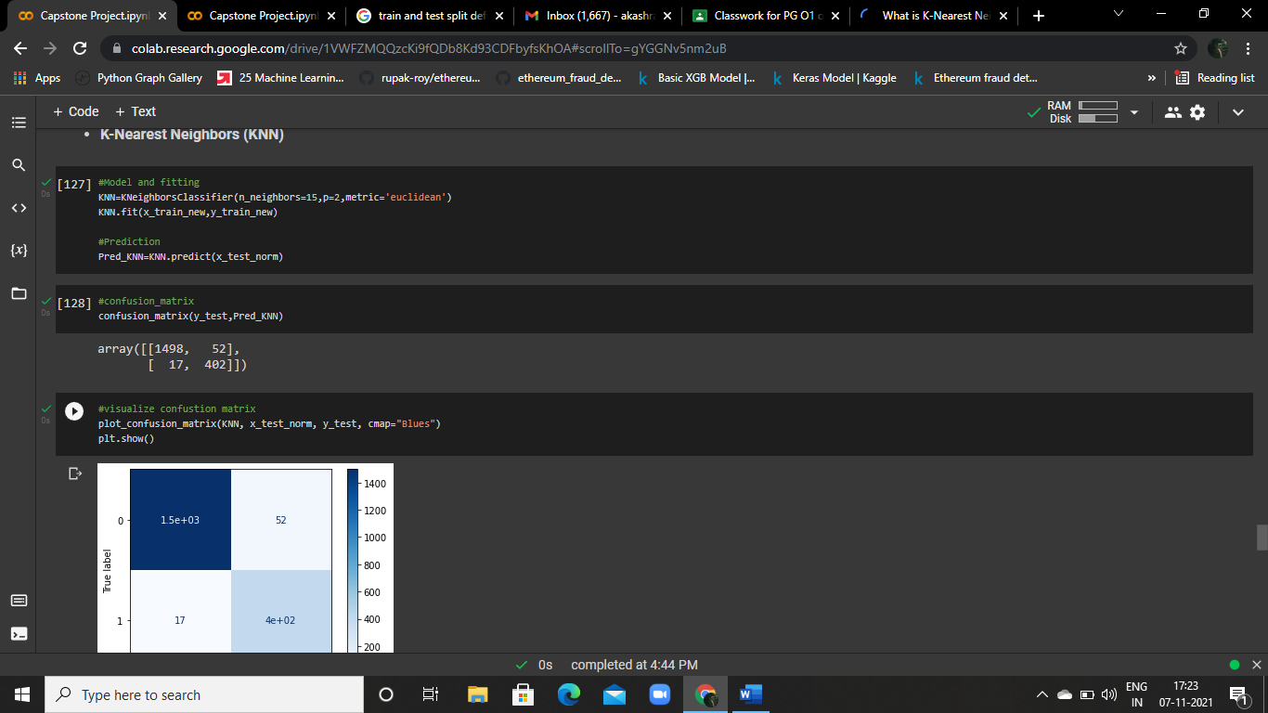

## 4.5.2 Prediction Process:

After fitting the data to the model. It’s time for prediction



## 4.5.3 Confusion Matrix:





Visualize the confusion matrix

## 4.5.4 Accuracy Score and Classification Report:

After doing all the process we have to conclude the model performance with accuracy score and classification report.

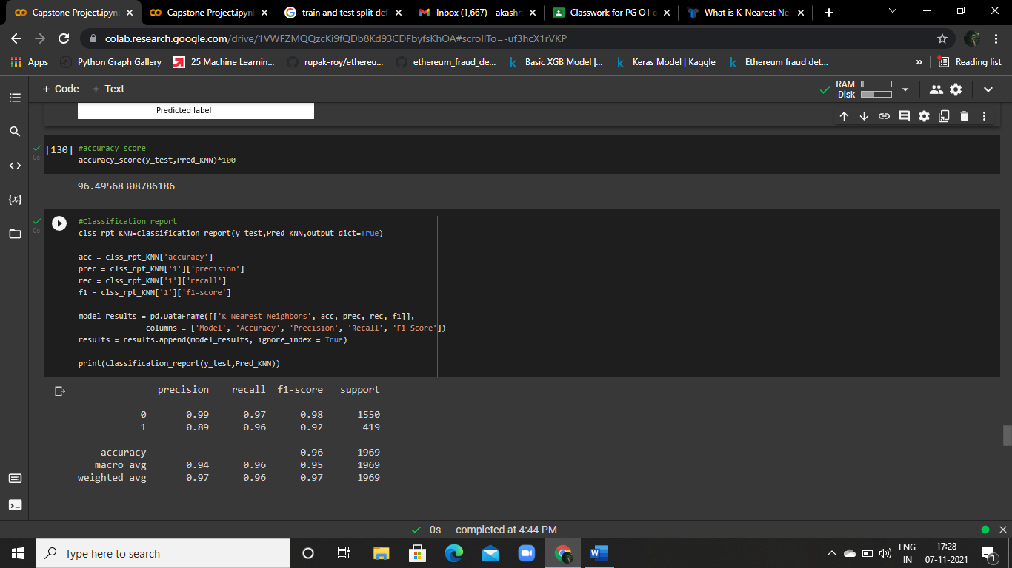

By Looking this figure the KNN Model Accuracy is 96% It’s good. Let’s see the other model accuracy then we conclude it which one is Best.

# 4.6 Voting Method for Some Models:

Voting is an ensemble machine learning algorithm. For regression, a voting ensemble involves making a prediction that is the average of multiple other regression models. A voting ensemble involves summing the predictions made by classification models or averaging the predictions made by regression models.

## 4.6.1 Pre Processing Pipeline:.

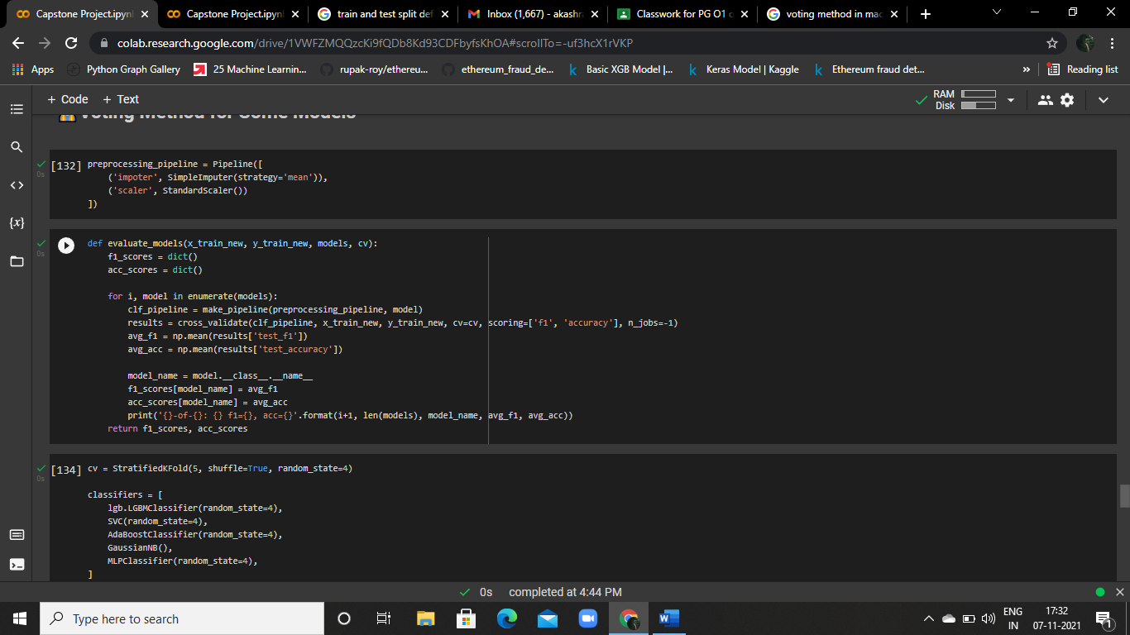

## 4.6.2 Evaluate Model:





## 4.6.3 Accuracy score and F1 Score:

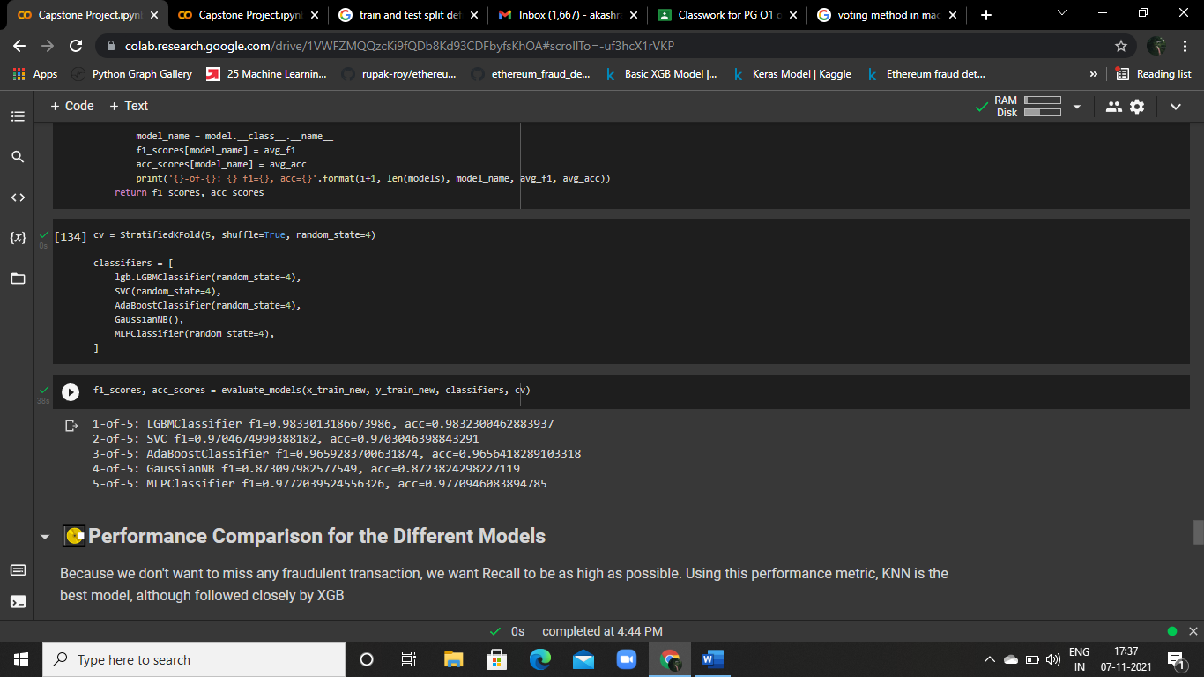

By Looking this figure the Evaluate Models Accuracy are,

|  |  |
| --- | --- |
| LGBM Classifier | 98% |
| SVC | 97% |
| AdaBoost Classifier | 96% |
| Gaussian NB | 87% |
| MLP Classifier | 97% |

It’s good to see this Results. Let’s see the Deep learning model accuracy then we conclude it which one is Best.

# 4.7 Artificial Neural Network

An ANN is based on a collection of connected units or nodes called artificial neurons, which loosely model the neurons in a biological brain.

## 4.7.1 Model Building and Fitting Process:

First thing is when we received the perfect data from the EDA process. Its time to serving the data to the models.

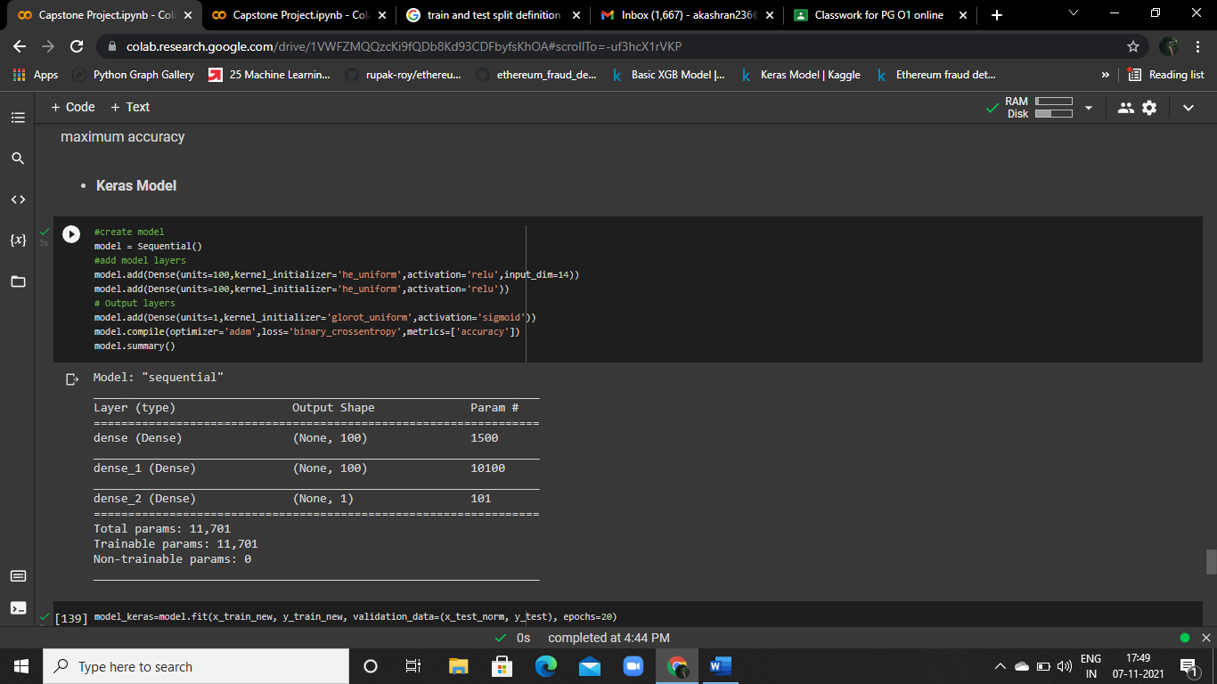

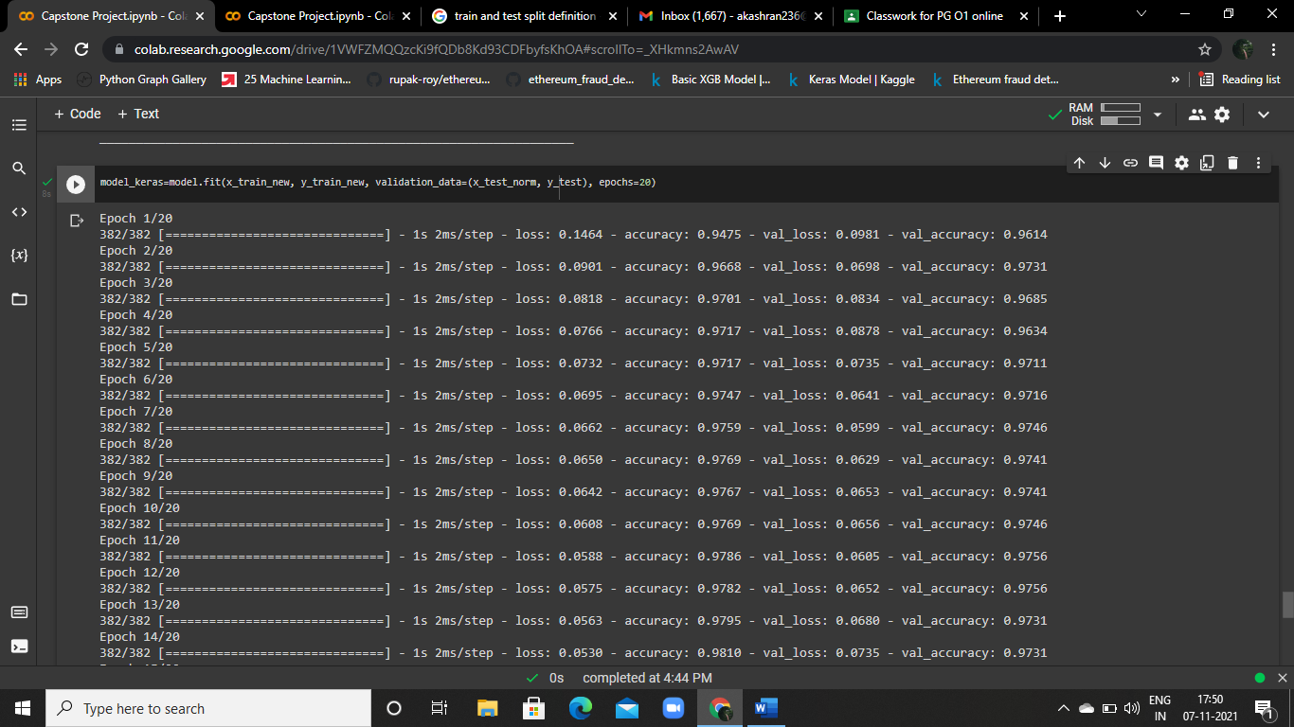

## 4.7.2 Prediction Process:

After fitting the data to the model. It’s time for prediction

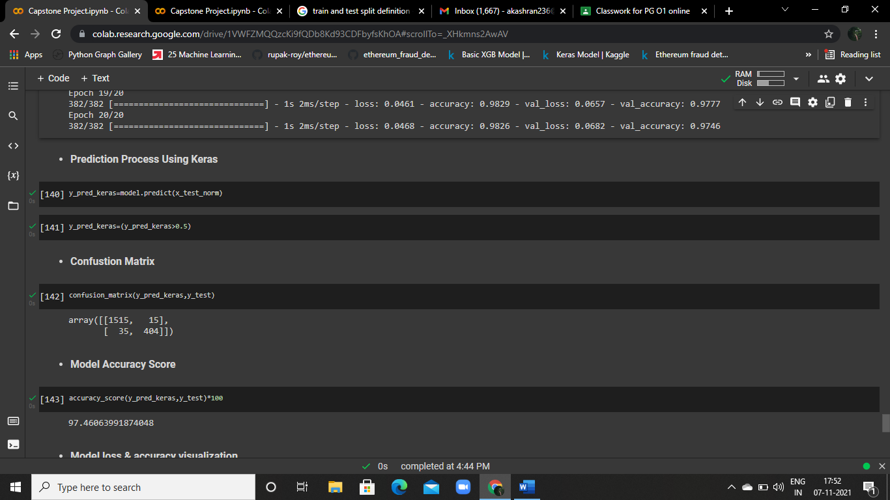

## 4.7.3 Confusion Matrix:



## 4.7.4 Accuracy Score:

After doing all the process we have to conclude the model performance with accuracy score.



By Looking this figure the ANN Model Accuracy is 97% It’s good. Let’s we conclude it which one is Best.

## 4.7.5 Model Loss and Accuracy Visualization:

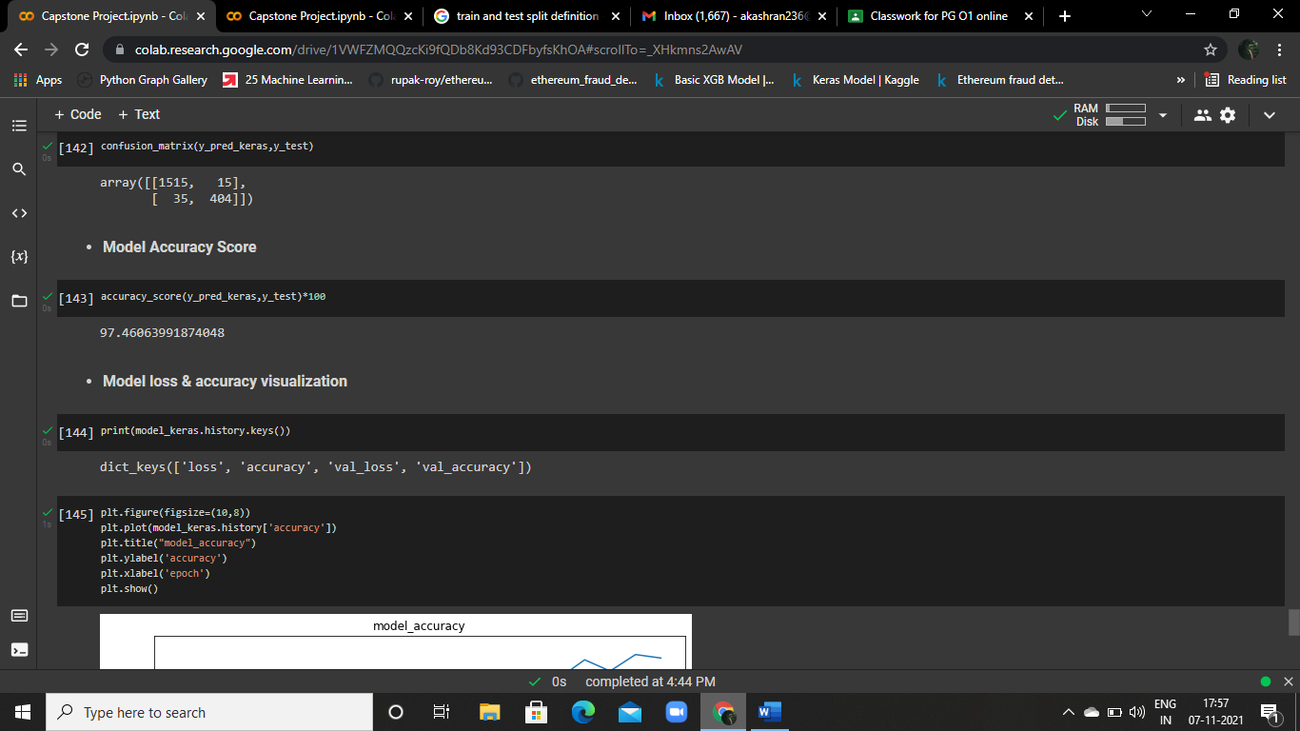

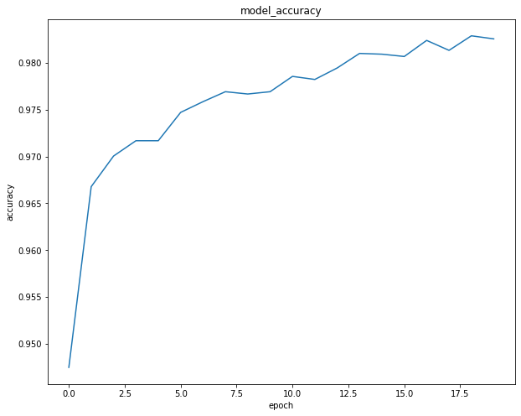

Visualization of model accuracy

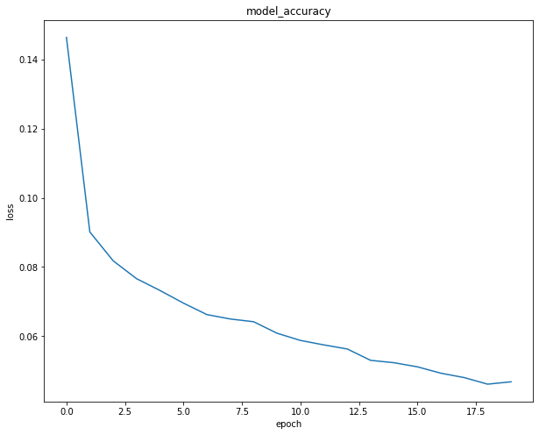

Visualization of model Loss

# C H A P T E R -5

**C O N C L U S I O N**

**________________________________________________________**

# 5.1 Performance Comparison for all the models:

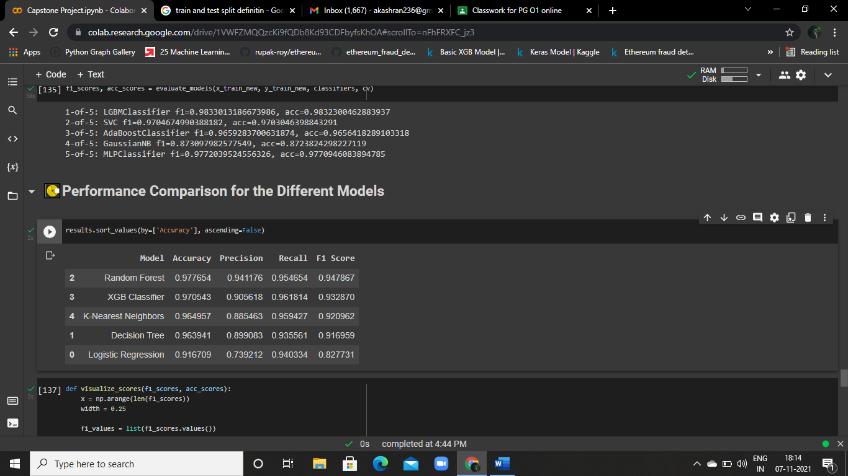



# 5.2 Conclusion:

* In this Project, we built a Multi models that could approximately Detecting a Fraud transactions of ETHEREUM given some information about the population.
* Looking the above all models that could give us a Model Accuracy are

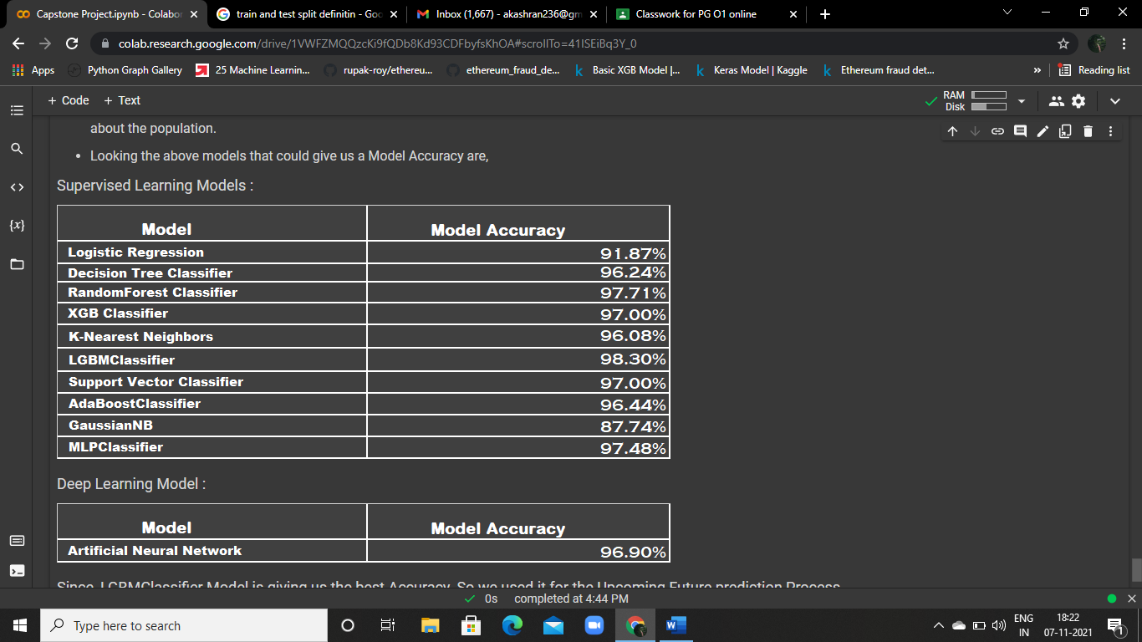

* Since, LGBM Classifier Model is giving us the best Accuracy 98%, so we used it for the Upcoming Future prediction Process.

**“ T H A N K Y O U ”**